Mineral Titles Act
NOTICE OF LAND CEASING TO BE A MINERAL TITLE AREA
Title Type and Number: | Exploration Licence 28239
Area Ceased on: | 14 December 2018
Area: | 4 Blocks, 12.68 km²
Locality: | JERVOIS RANGE
Name of Applicant(s)/Holder(s): | 100% AUSTRALIA MINING & GEMSTONE CO. PTY LTD [ACN. 114 395 247]
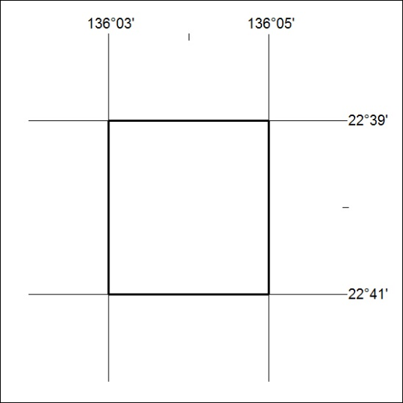

582/18

