Mineral Titles Act
NOTICE OF LAND CEASING TO BE A MINERAL TITLE AREA
Title Type and Number: | Exploration Licence 28841
Area Ceased on: | 30 January 2019
Area: | 5 Blocks, 16.50 km²
Locality: | VICTORIA RIVER DOWNS
Name of Applicant(s)/Holder(s): | 100% AUSTRALIA MINING & GEMSTONE CO. PTY LTD [ACN. 114 395 247]
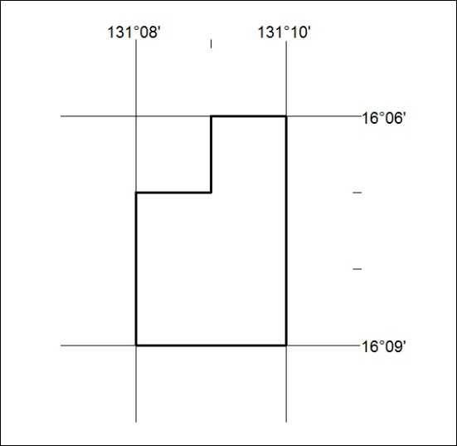

30/19

Mineral Titles Act
NOTICE OF LAND CEASING TO BE A MINERAL TITLE AREA
Title Type and Number: | Exploration Licence 31225
Area Ceased on: | 30 January 2019
Area: | 49 Blocks, 155.05 km²
Locality: | JINKA
Name of Applicant(s)/Holder(s): | 100% TERRITORY LITHIUM PTY LTD [ACN. 610 691 033]
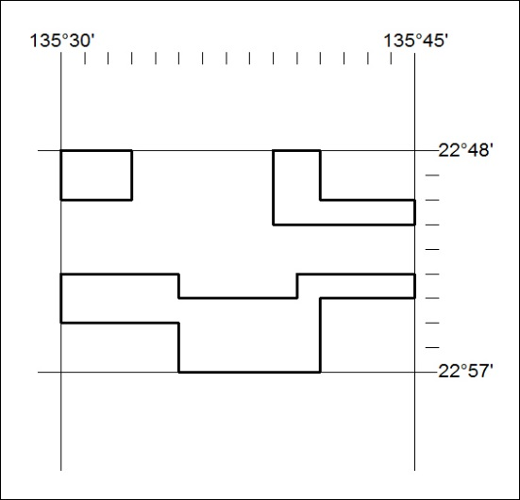

31/19

Mineral Titles Act
NOTICE OF LAND CEASING TO BE A MINERAL TITLE AREA
Title Type and Number: | Exploration Licence 31579
Area Ceased on: | 30 January 2019
Area: | 53 Blocks, 148.02 km²
Locality: | BARKLY
Name of Applicant(s)/Holder(s): | 100% TRUSCOTT MINING CORPORATION LTD [ACN. 116 420 378]
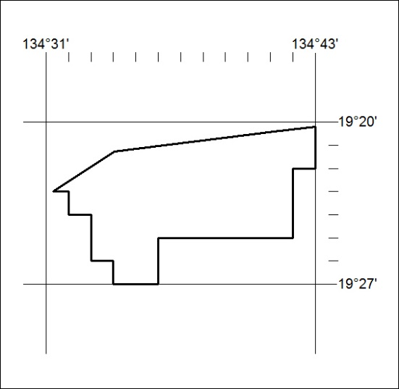

32/19

