Mineral Titles Act 2010
NOTICE OF LAND CEASING TO BE A MINERAL TITLE AREA
Title Type and Number: | Exploration Licence 24839
Area Ceased on: | 02 May 2019
Area: | 14 Blocks, 26.94 km²
Locality: | MACDONNELL RANGES
Name of Applicant(s)/Holder(s): | 100% GENESIS RESOURCES LIMITED [ACN. 114 787 469]
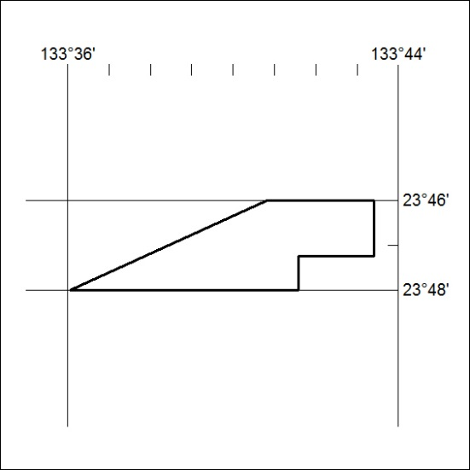

144/19

Mineral Titles Act 2010
NOTICE OF LAND CEASING TO BE A MINERAL TITLE APPLICATION AREA
Title Type and Number: | Exploration Licence 31852
Area Ceased on: | 01 May 2018
Area: | 250 Blocks, 793.60 km²
Locality: | REYNOLDS RANGE
Name of Applicant(s)/Holder(s): | 100% BOAB RESOURCES PTY LTD [ACN. 612 043 302]
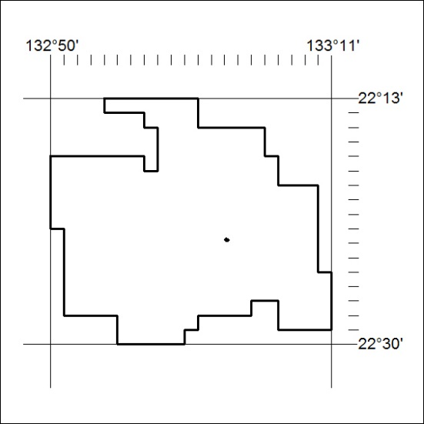

145/19
Mineral Titles Act 2010
NOTICE OF LAND CEASING TO BE A MINERAL TITLE APPLICATION AREA
Title Type and Number: | Exploration Licence 31853
Area Ceased on: | 01 May 2019
Area: | 250 Blocks, 818.01 km²
Locality: | INVERWAY
Name of Applicant(s)/Holder(s): | 100% GHOSTGUM RESOURCES PTY LTD [ACN. 625 092 542]
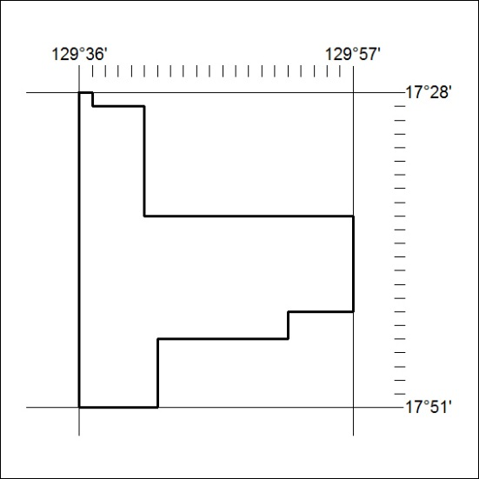

146/19

Mineral Titles Act 2010
NOTICE OF LAND CEASING TO BE A MINERAL TITLE APPLICATION AREA
Title Type and Number: | Exploration Licence 31854
Area Ceased on: | 01 May 2019
Area: | 250 Blocks, 818.64 km²
Locality: | LIMBUNYA
Name of Applicant(s)/Holder(s): | 100% GHOSTGUM RESOURCES PTY LTD [ACN. 625 092 542]
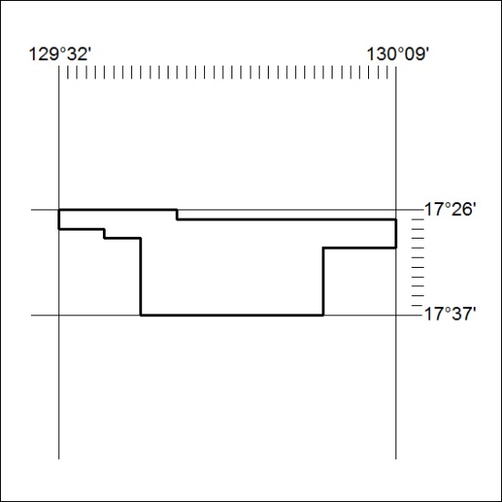

147/19

Mineral Titles Act 2010
NOTICE OF LAND CEASING TO BE A MINERAL TITLE APPLICATION AREA
Title Type and Number: | Exploration Licence 31945
Area Ceased on: | 01 May 2019
Area: | 215 Blocks, 674.08 km²
Locality: | TODD
Name of Applicant(s)/Holder(s): | 100% COPPERBUSH RESOURCES PTY LTD [ACN. 627 018 035]
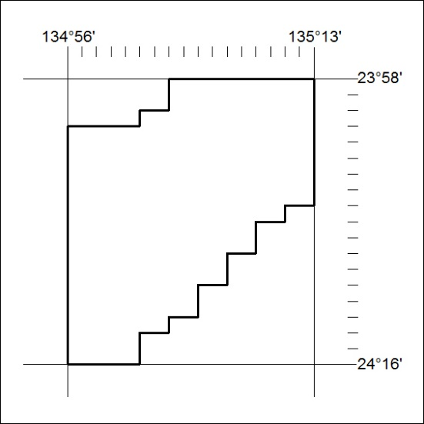

148/19

Mineral Titles Act 2010
NOTICE OF LAND CEASING TO BE A MINERAL TITLE APPLICATION AREA
Title Type and Number: | Exploration Licence 32017
Area Ceased on: | 01 May 2019
Area: | 234 Blocks, 728.22 km²
Locality: | HALE
Name of Applicant(s)/Holder(s): | 100% COPPERBUSH RESOURCES PTY LTD [ACN. 627 018 035]
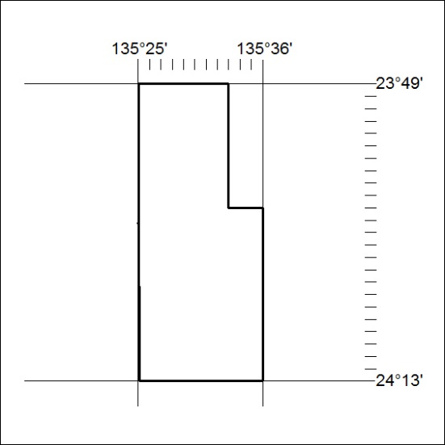

149/19

