Mineral Titles Act 2010
NOTICE OF LAND CEASING TO BE A MINERAL TITLE AREA
Title Type and Number: | Exploration Licence 27412
Area Ceased on: | 28 January 2020
Area: | 9 Blocks, 29.67 km²
Locality: | NEWRY
Name of Applicant(s)/Holder(s): | 50% BRALICH HOLDINGS PTY LTD [ACN. 060 990 632], 50% RIDING RESOURCES PTY LTD [ACN. 009 456 455]
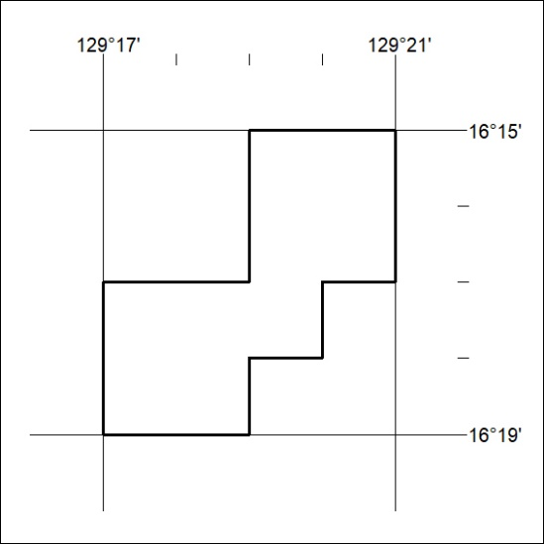

36/20

Mineral Titles Act 2010
NOTICE OF LAND CEASING TO BE A MINERAL TITLE AREA
Title Type and Number: | Exploration Licence 31947
Area Ceased on: | 29 January 2020
Area: | 38 Blocks, 118.73 km²
Locality: | ALICE SPRINGS
Name of Applicant(s)/Holder(s): | 100% CROSSLAND NICKEL PTY LTD* [ACN. 099 477 915]
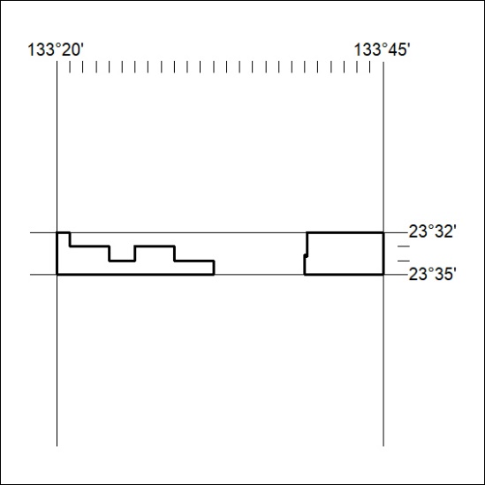

37/20

Mineral Titles Act
NOTICE OF GRANT OF A MINERAL TITLE
Title Type and Number: | Exploration Licence 32116
Granted: | 30 January 2020, for a period of 6 Years
Area: | 250 Blocks, 796.01 km²
Locality: | DAVENPORT RANGE
Name of Holder/s: | 100% WOODLEIGH NOMINEES PTY LIMITED [ACN. 050 120 057]
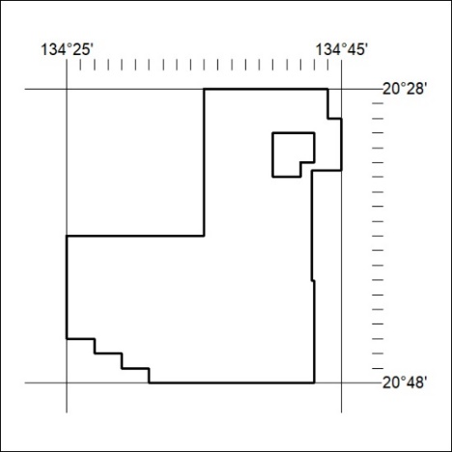
Area granted is indicated above. The titleholder is not permitted to exercise occupational rights on any land that is subject to a development title, or an application for a development title. Any land the subject of a Reserved Land gazettal under the Mineral Titles Act and all land vested in the Commonwealth of Australia is also excluded by description but not excised from the grant area.

38/20

Mineral Titles Act
NOTICE OF GRANT OF A MINERAL TITLE
Title Type and Number: | Exploration Licence 32117
Granted: | 29 January 2020, for a period of 6 Years
Area: | 250 Blocks, 794.25 km²
Locality: | ALGAMBA
Name of Holder/s: | 100% ELEMENTZONE PTY LTD [ACN. 633 108 906]
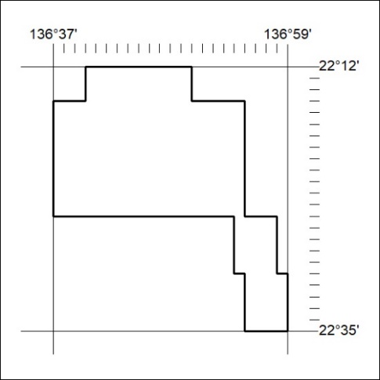
Area granted is indicated above. The titleholder is not permitted to exercise occupational rights on any land that is subject to a development title, or an application for a development title. Any land the subject of a Reserved Land gazettal under the Mineral Titles Act and all land vested in the Commonwealth of Australia is also excluded by description but not excised from the grant area.

39/20

