Mineral Titles Act 2010
NOTICE OF LAND CEASING TO BE A MINERAL TITLE AREA
Title Type and Number: | Exploration Licence 29068
Area Ceased on: | 14 April 2020
Area: | 4 Blocks, 13.36 km²
Locality: | McKINLAY RIVER
Name of Applicant(s)/Holder(s): | 100% ISMINS PTY LTD [ACN. 141 217 343]
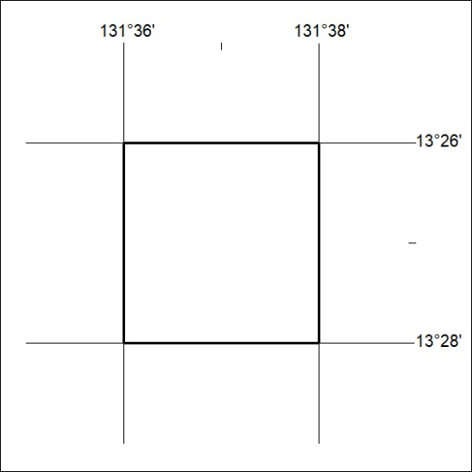
164/20

