Mineral Titles Act 2010
NOTICE OF LAND CEASING TO BE A MINERAL TITLE AREA
Title Type and Number: | Exploration Licence 32082
Area Ceased on: | 06 August 2020
Area: | 35 Blocks, 114.25 km²
Locality: | MONTEJINNI
Name of Applicant(s)/Holder(s): | 100% CENTREX QLD EXPLORATION PTY LTD [ACN. 152 383 054]
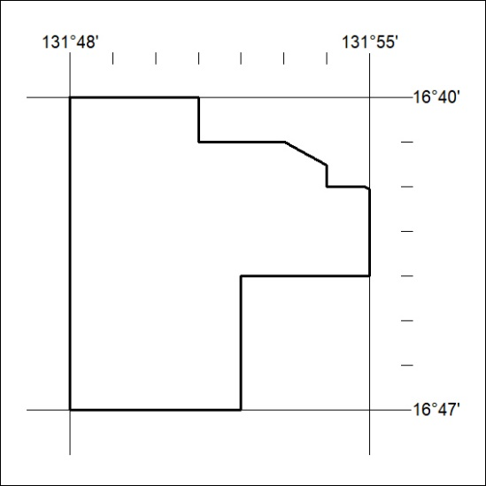

255/20

Mineral Titles Act 2010
NOTICE OF LAND CEASING TO BE A MINERAL TITLE AREA
Title Type and Number: | Exploration Licence 32091
Area Ceased on: | 06 August 2020
Area: | 11 Blocks, 36.14 km²
Locality: | MONTEJINNI
Name of Applicant(s)/Holder(s): | 100% CENTREX QLD EXPLORATION PTY LTD [ACN. 152 383 054]
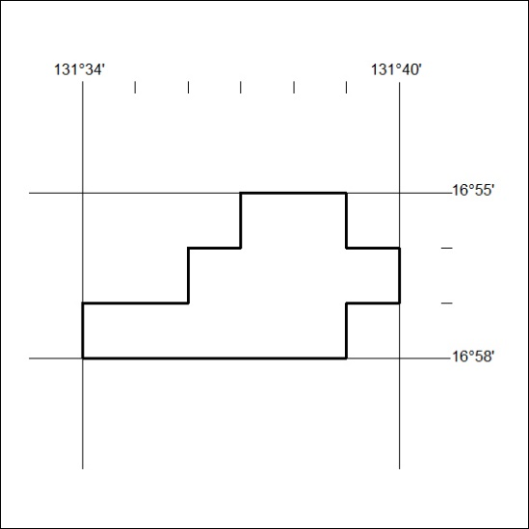

256/20

