Mineral Titles Act 2010
NOTICE OF LAND CEASING TO BE A MINERAL TITLE APPLICATION AREA
Title Type and Number: | Exploration Licence 32319
Area Ceased on: | 07 August 2020
Area: | 31 Blocks, 97.84 km²
Locality: | NARWIETOOMA
Name of Applicant(s)/Holder(s): | 100% SCRIVEN EXPLORATION PTY LTD [ACN. 006 264 615]
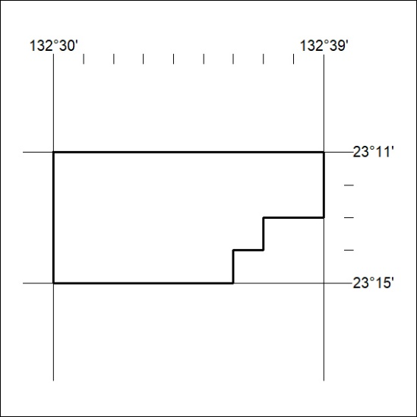

257/20

