Mineral Titles Act 2010
NOTICE OF LAND CEASING TO BE A MINERAL TITLE AREA
Title Type and Number: | Exploration Licence 23722
Area Ceased on: | 17 September 2020
Area: | 5 Blocks, 5.04 km²
Locality: | BYNOE
Name of Applicant(s)/Holder(s): | 50% EARTHROWL John Anthony, 10% DOLWAVE PTY. LIMITED [ACN. 082 154 372], 10% HASS Rodney Boyce, 10% KIMALTA PTY. LIMITED [ACN. 066 662 022], 10% POATINA PTY. LIMITED [ACN. 009 614 171], 10% STARBASE TWENTY TWO PTY LTD* [ACN. 009 613 585]
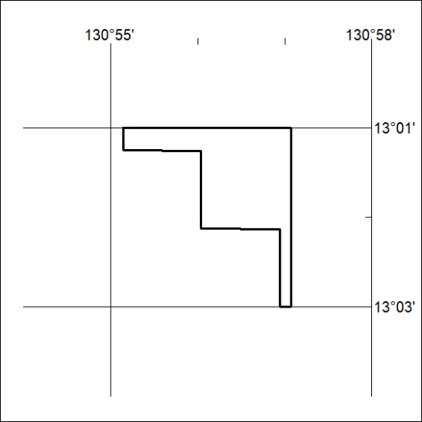

317/20

