Mineral Titles Act 2010
NOTICE OF LAND CEASING TO BE A MINERAL TITLE AREA
Title Type and Number: | Exploration Licence 31224
Area Ceased on: | 12 October 2020
Area: | 23 Blocks, 72.83 km²
Locality: | AILERON
Name of Applicant(s)/Holder(s): | 100% ARAFURA RESOURCES LIMITED [ACN. 080 933 455]
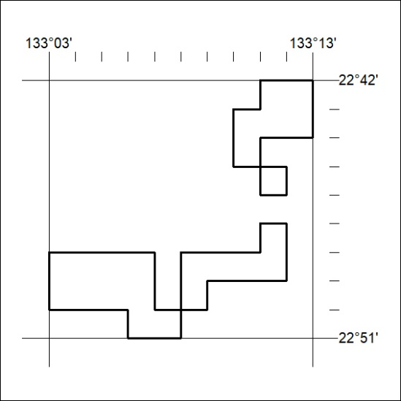

332/20

