

**TARLEE-S3**

**STRATIGRAPHIC DRILL HOLE**

**ENVIRONMENTAL PLAN SUMMARY**

**TABLE OF CONTENTS**

**1. INTRODUCTION ..........................................................................................................................................3**

**2. DESCRIPTION OF ACTIVITY..........................................................................................................................4**

**3. DESCRIPTION OF THE ENVIRONMENT.........................................................................................................4**

**4. DESCRIPTION OF THE ACTIVITY IN RELATION TO THE ENVIRONMENT ........................................................5**

**5. ENVIRONMENTAL RISKS OF PROPOSED ACTIVITY AND CONTROL MEASURES ............................................5**

**6. CONSULTATION ..........................................................................................................................................6**

**7. PANGAEA RESOURCES LIAISON PERSONNEL...............................................................................................6**

**1. INTRODUCTION**

EP167 is located approximately 350 km southeast of Darwin in the Northern Territory (NT) in the western McArthur Basin. The basin is essentially unexplored for hydrocarbons, either conventional or unconventional, and from a shale gas or oil perspective, there is limited information on thermal maturity, total organic carbon (TOC), porosity, permeability, gas content or saturation. The tenement falls within the Roper Gulf Shire.

The proposed Tarlee-S3 stratigraphic drill hole will be located in the south-east portion of EP167 in central Northern Territory, approximately 150 km south of Katherine and approximately 40 km west of the town of Larrimah along Stuart Highway. A location map and coordinates of the activity are provided in Figure 1.

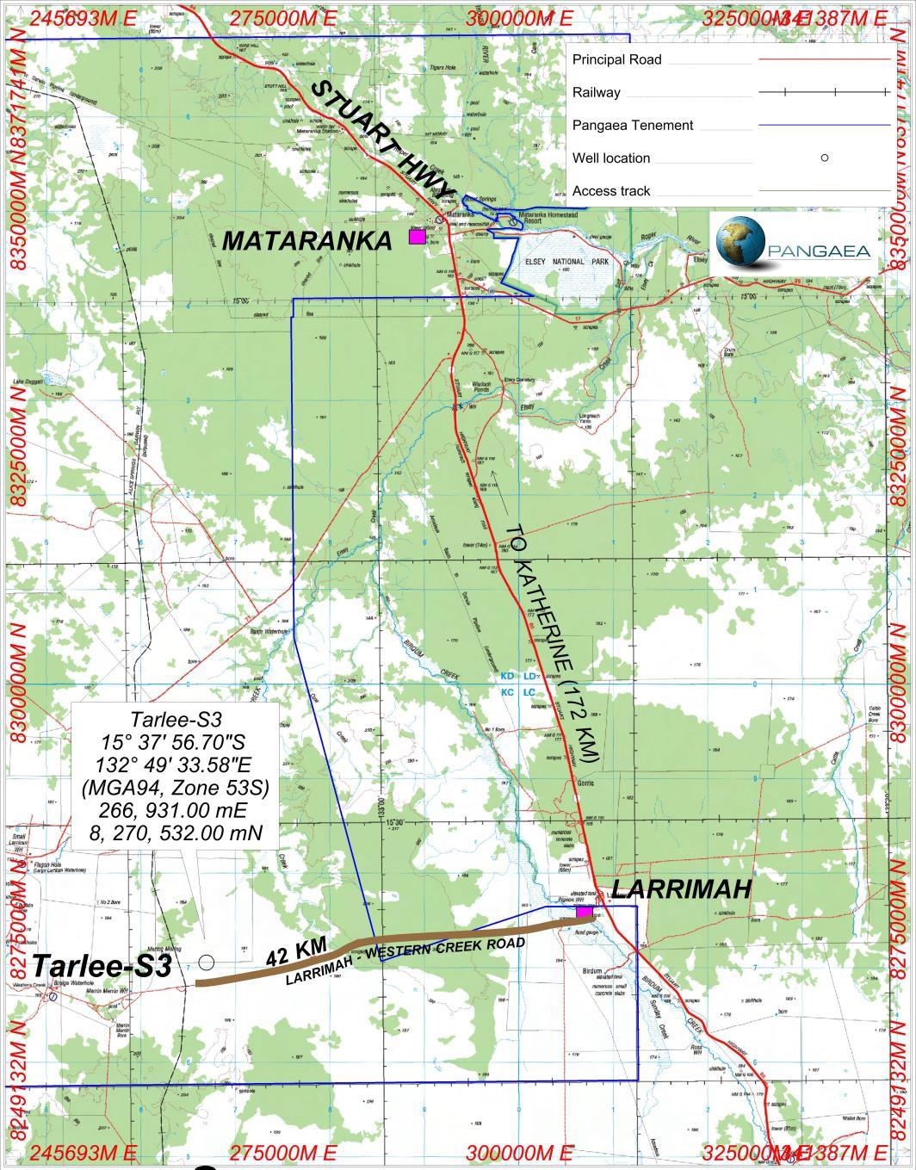

***Figure 1: Tarlee-S3 Drill Hole site within EP 167***

**2. DESCRIPTION OF ACTIVITY**

The objectives of the Tarlee-S3 Drill Hole in EP167 are to:

• Identify thick intervals of organic-rich shale within the wet to dry gas hydrocarbon generation windows;

• Confirm the stratigraphy and tie this stratigraphy to the regional seismic interpretation;

• Collect velocity information to improve the time to depth conversion for the regional seismic interpretation; and

• Evaluate the thermal maturity, gas content, gas saturation, gas composition, mineralogy, porosity and permeability of the shale units within the Roper Group from core and wireline logs.

By way of summary, the evaluation methodology and data acquisition will comprise mainly of coring and wireline logging operations. The final well will not be used to produce oil and gas, therefore Pangaea will plug and abandon Tarlee-S3 by setting cement plugs in the well to isolate all porous formations, aquifers and potential reservoirs.

**3. DESCRIPTION OF THE ENVIRONMENT**

The region’s climate is *‘semi-arid tropical, with rainfall concentrated in the wet season months between November and April. Though rainfall can be variable from year to year, there is a distinct gradient of decreasing mean annual falls from 850mm in the north to less than 500mm’* in southern areas of the adjacent EP168, with nearly all the rainfall occurring between November and April (see Williams *et al.*

19971, Hennessy *et al.* 20042). The mean maximum temperature varies from 27°C in July to 40°C and

beyond in November.

Condition is generally good across much of the bioregion, reflected in a continental stress class score of 5. However, as one of the most fertile areas in northern Australia, and because of its proximity to Darwin and Katherine, the bioregion is one of the most developed in the Northern Territory. About 8% of the region has been cleared for horticultural production or intensive grazing, and more extensive development is being proposed3.

The drilling campaign, inclusive of access routes to the drill sites, will intersect with the Banjo land system. The Banjo land system consists of almost level to gently undulating plains on the plateau surface that lack drainage lines. Consisting of variable depth red earth soils with or without gravel; mixed eucalypt woodlands and perennial grasses, the systems are generally suitable for pasture improvement and have moderate to high grazing potential. The Banjo land system consists of vegetation that has a relatively low forage quality in the dry season but it can benefit from strategic burning to manage woody thickening4.

1 Williams, R.J., Cook, G.D., Ludwig, J.L. and Tongway, D.L. (1997). Torch, trees, teeth and tussocks: disturbance in the tropical savannas of the

Northern Territory (Australia). In: Frontiers in Ecology. Building the Links. Eds. N. Klomp and I. Lunt. Elsevier, Oxford: pp55-66.

2 Hennessy, K., Page, C., McInnes, K., Walsh, K., Pittock, B., Bathols, J, and Suppiah, R. (2004). Climate Change in the Northern Territory. Consultancy

report for the Northern Territory Department of Infrastructure, Planning and Environment. CSIRO, Melbourne.

3 Department of Land & Resource Management (2014) Daly Basin – Bioregional Description. Downloaded at [http://lrm.nt.gov.au/plants-and-](http://lrm.nt.gov.au/plants-and-animals/herbarium/nature/bioregional/dalybasin#.U5RknV5Rf1o)

[animals/herbarium/nature/bioregional/dalybasin#.U5RknV5Rf1o](http://lrm.nt.gov.au/plants-and-animals/herbarium/nature/bioregional/dalybasin#.U5RknV5Rf1o)

4 Northern Territory Government (no date) Land Condition Guide - Sturt Plateau District, Understanding the productivity of grazing lands. Produced

in association with the Northern Territory Cattlemen’s Association as part of the Caring for Our Country project “Grazing Land Management –

Demonstration, Continuation and Evaluation”.

**4. DESCRIPTION OF THE ACTIVITY IN RELATION TO THE ENVIRONMENT**

The Tarlee-S3 stratigraphic drill hole has been designed with due consideration of the surface and subsurface environments. The site has been selected and will be constructed to avoid large scale levelling and clearance of vegetation.

The drilling operation has been designed to:

• Isolate permeable zones within the well;

• Protect potable water aquifers;

• Prevent uncontrolled discharge of water, gas or oil from the well while drilling; and

• Prevent cross flow between potential aquifers, reservoirs or formations.

These objectives are achieved by the appropriate selection of:

• Surface equipment (including drilling rig and well control equipment);

• Surface facilities/pits for the containment of drilling fluids;

• Casings and setting of casing depths to ensure aquifers are isolated;

• Drilling techniques;

• Down hole technology; and

• Well abandonment procedures.

**5. ENVIRONMENTAL RISKS OF PROPOSED ACTIVITY AND CONTROL MEASURES**

**Fauna and flora**

Potential impacts to surrounding flora and fauna at the well site will be assessed and reduced by measures including weed and pest inspections on all vehicles and personnel clothing prior to arrival at site and the use of signage and appropriate fencing.

**Groundwater**

The well will be grouted and completed according to industry’s best practice for sealing, plugging and decommissioning. Any well that encounters an artesian or sub-artesian flow will be sealed to prevent contamination or cross-contamination of aquifers and will be sealed with cement plugs to prevent surface discharge of groundwater. Appropriate sedimentation and erosion control measures will be put in place at the well site. The amount of hazardous material stored and used on site shall be kept to a minimum.

**Noise and surface**

Speed limits will be enforced on access tracks to limit and minimise dust and noise generation. Vehicular movements to and from the work site will be minimised by travel during daylight hours and be compliant with land access agreements. Soil erosion will be minimised by the use of existing tracks, deviating around creeks, river banks and naturally formed depressions and not accessing roads in wet conditions.

**Waste management**

Waste will be stored in suitable receptacles and disposed of accordingly at municipal managed locations. Hazardous material shall be transported, stored and handled in accordance with the requirements of the relevant legislation and guidelines.

**6. CONSULTATION**

During the past several months Pangaea has consulted with stakeholders, which has included:

• A detailed cultural heritage assessment and clearance process with the Northern Land Council and

Traditional Owners;

• Negotiating and signing of voluntary access agreements with directly-affected Pastoralists;

• Involvement in joint NTDME-APPEA-CSIRO public forums and information nights held in major towns and centres in NT;

• Direct engagement with communities and focused groups at exhibition booths during district and agricultural shows eg. Katherine District Shows ( 18-19 July, 2014)

• Notifying local government councils, police authorities and local businesses of exploration activities; and

• Complying with legislation and guidelines from the NT Department of Mines and Energy and other

regulatory agencies eg. Dep’t of Transport and Dep’t of Infrstructure.

Pangaea’s engagement process is aimed to identify and address any issues of concern, reach agreement and in general engage in goodwill communication.

Pangaea will continue this process with stakeholders throughout the life of the project.

**7. PANGAEA RESOURCES LIAISON PERSONNEL**

|  |  |  |
| --- | --- | --- |
| **Sydney Office** | | |
| External Affairs Manager | [Ricky.Mantaring@pangaea.net.au](mailto:Ricky.Mantaring@pangaea.net.au) | Phone: (02) 9017 9600 |