Mineral Titles Act
NOTICE OF LAND CEASING TO BE A MINERAL TITLE AREA
Title Type and Number: | Exploration Licence 29966
Area Ceased on: | 26 March 2018
Area: | 34 Blocks, 113.69 km²
Locality: | BATCHELOR
Name of Applicant(s)/Holder(s): | 100% NORTH QUEENSLAND MINING PTY LTD [ACN. 152 890 643]
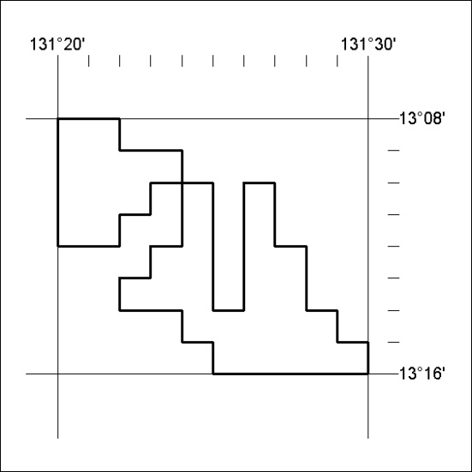

122/18

