Mineral Titles Act
NOTICE OF LAND CEASING TO BE A MINERAL TITLE AREA
Title Type and Number: | Extractive Mineral Exploration Licence 31836
Area Ceased on: | 25 May 2018
Area: | 4 Blocks, 8.51 km²
Locality: | KOOLPINYAH
Name of Applicant(s)/Holder(s): | 100% OSTOJIC GROUP PTY LTD* [ACN. 009 629 805]
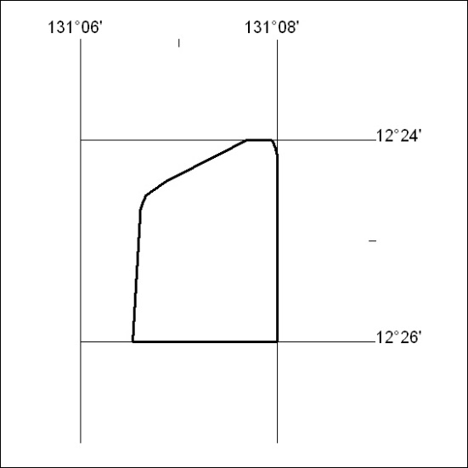

204/18

Mineral Titles Act
NOTICE OF LAND CEASING TO BE A MINERAL TITLE
Title Type and Number: | Extractive Mineral Permit 31840
Area ceased on: | 25 May 2018
Area: | 67.00 Hectare
Locality: | KOOLPINYAH
Name of Applicants(s)Holder(s): | 100% OSTOJIC GROUP PTY LTD* [ACN. 009 629 805]
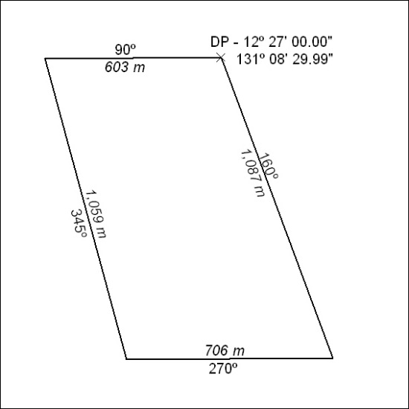

205/18

Corrigendum
Notice Number 157/18 appearing in MN56/18 on 4 May 2018 is hereby cancelled and replaced by the following:

Mineral Titles Act
NOTICE OF LAND CEASING TO BE A MINERAL TITLE AREA
Title Type and Number: | Exploration Licence 30040
Area Ceased on: | 04 May 2018
Area: | 20 Blocks, 56.11 km²
Locality: | DAVENPORT RANGE
Name of Applicant(s)/Holder(s): | 20% DUNNELL Kevin, 20% FALZON Angelo, 20% HALL Mary Anne, 20% HALL Thomas Raymond, 20% HOPPE Andrew Steven
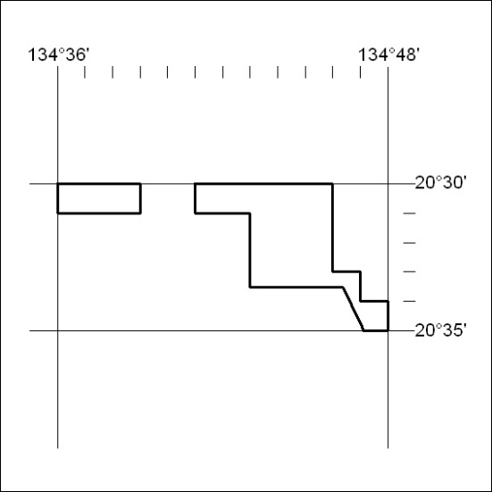

206/18

