Mineral Titles Act
NOTICE OF LAND CEASING TO BE A MINERAL TITLE AREA
Title Type and Number: | Exploration Licence 31024
Area Ceased on: | 19 June 2018
Area: | 2 Blocks, 6.69 km²
Locality: | NOONAMAH
Name of Applicant(s)/Holder(s): | 50% FALKO Wladimir, 50% N.T. GOLD PTY LTD * [ACN. 009 625 870]
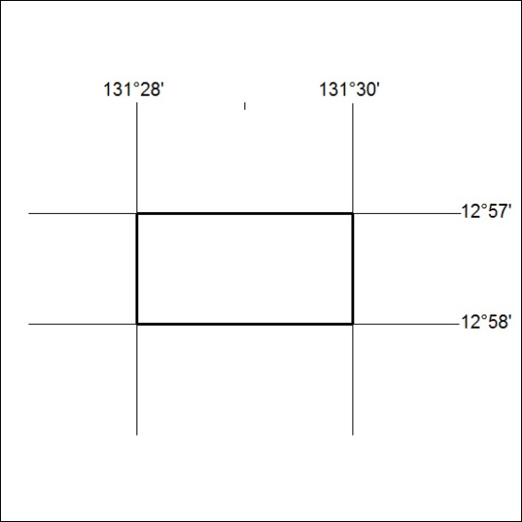

273/18

