Mineral Titles Act
NOTICE OF LAND CEASING TO BE A MINERAL TITLE
Title Type and Number: | Extractive Mineral Permit 22239
Area ceased on: | 26 June 2018
Area: | 3.00 Hectare
Locality: | UNDOOLYA
Name of Applicants(s)Holder(s): | 100% NORTH CONCRETE (NT) PTY LTD [ACN. 128 802 997]
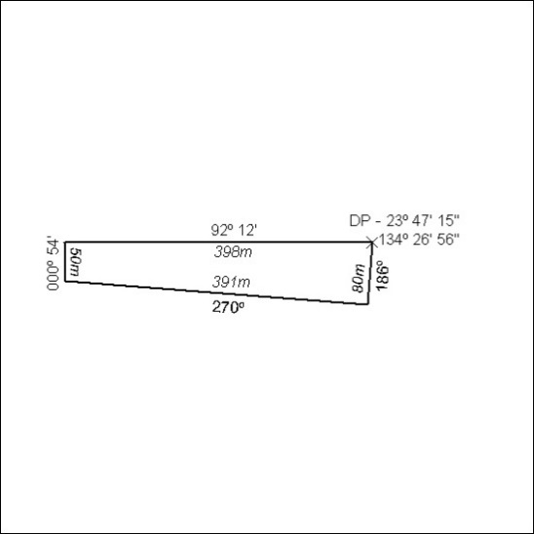

277/18

Mineral Titles Act
NOTICE OF LAND CEASING TO BE A MINERAL TITLE
Title Type and Number: | Extractive Mineral Permit 28832
Area ceased on: | 26 June 2018
Area: | 3.00 Hectare
Locality: | UNDOOLYA
Name of Applicants(s)Holder(s): | 100% NORTH CONCRETE (NT) PTY LTD [ACN. 128 802 997]
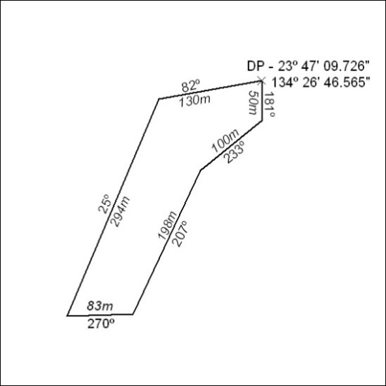

278/18

