Mineral Titles Act
NOTICE OF LAND CEASING TO BE A MINERAL TITLE
Title Type and Number: | Mineral Lease (Northern) 1155
Area ceased on: | 18 July 2018
Area: | 614.00 Hectares
Locality: | MARY RIVER
Name of Applicants(s)Holder(s): | 100% PRIMARY MINERALS NL [ACN. 153 582 962]
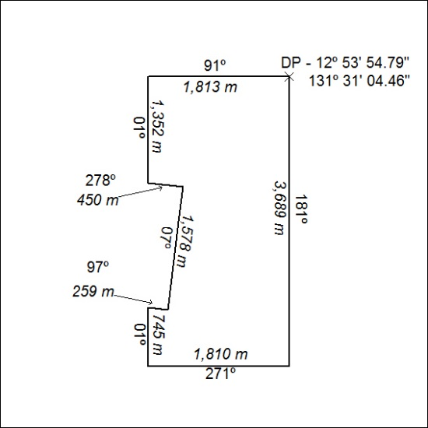

309/18

Mineral Titles Act
NOTICE OF LAND CEASING TO BE A MINERAL TITLE AREA
Title Type and Number: | Exploration Licence 30205
Area Ceased on: | 17 July 2018
Area: | 42 Blocks, 135.05 km²
Locality: | DAVENPORT RANGE
Name of Applicant(s)/Holder(s): | 20% DUNNELL Kevin, 20% FALZON Angelo, 20% HALL Mary Anne, 20% HALL Thomas Raymond, 20% HOPPE Andrew Steven
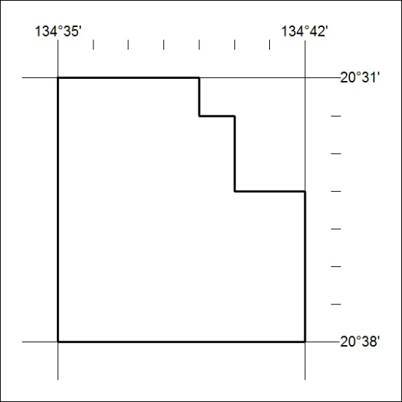

310/18

