Mineral Titles Act
NOTICE OF LAND CEASING TO BE A MINERAL TITLE AREA
Title Type and Number: | Exploration Licence 8766
Area Ceased on: | 15 October 2018
Area: | 45 Blocks, 144.46 km²
Locality: | WINNALL
Name of Applicant(s)/Holder(s): | 100% PRODIGY GOLD NL* [ACN. 009 127 020]
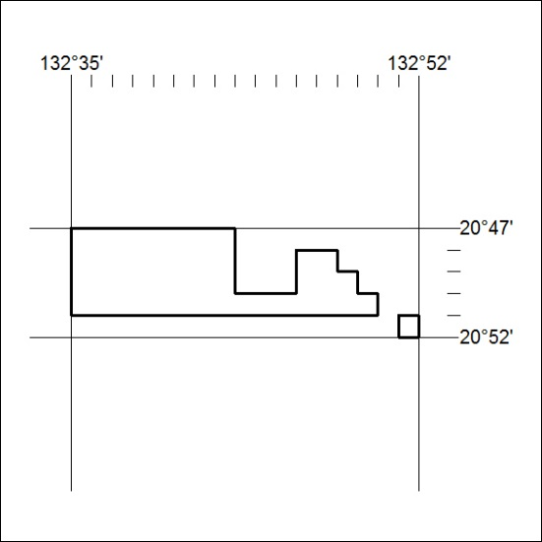

445/18

Mineral Titles Act
NOTICE OF LAND CEASING TO BE A MINERAL TITLE AREA
Title Type and Number: | Exploration Licence 30222
Area Ceased on: | 15 October 2018
Area: | 179 Blocks, 582.69 km²
Locality: | BRUNCHILLY
Name of Applicant(s)/Holder(s): | 100% TERRITORY PHOSPHATE PTY LTD [ACN. 130 065 351]
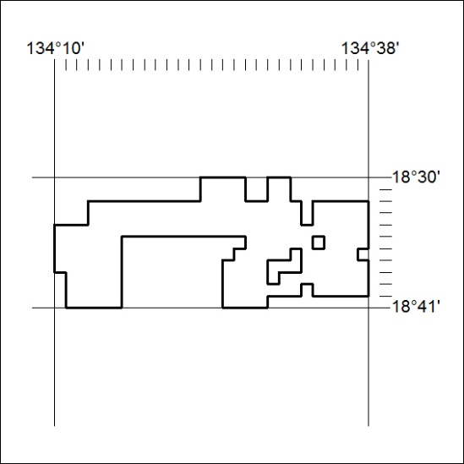

446/18

Mineral Titles Act
NOTICE OF LAND CEASING TO BE A MINERAL TITLE AREA
Title Type and Number: | Exploration Licence 30223
Area Ceased on: | 15 October 2018
Area: | 143 Blocks, 464.98 km²
Locality: | MUNKADERRY
Name of Applicant(s)/Holder(s): | 100% TERRITORY PHOSPHATE PTY LTD [ACN. 130 065 351]
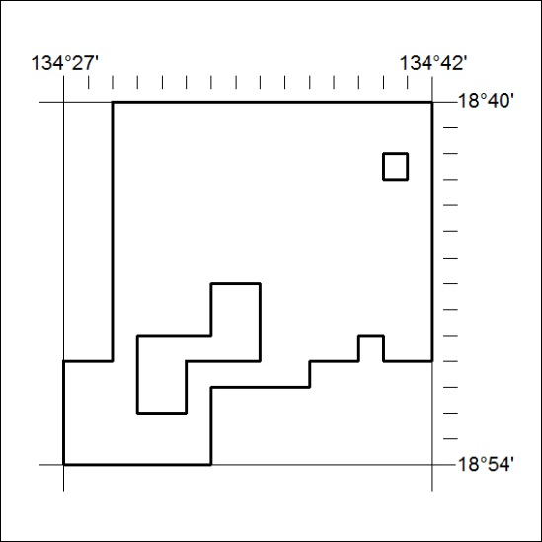

447/18

Mineral Titles Act
NOTICE OF LAND CEASING TO BE A MINERAL TITLE AREA
Title Type and Number: | Exploration Licence 30224
Area Ceased on: | 15 October 2018
Area: | 191 Blocks, 620.89 km²
Locality: | BRUNCHILLY
Name of Applicant(s)/Holder(s): | 100% TERRITORY PHOSPHATE PTY LTD [ACN. 130 065 351]
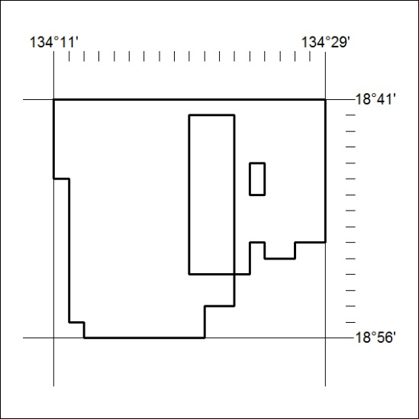

448/18

Mineral Titles Act
NOTICE OF LAND CEASING TO BE A MINERAL TITLE AREA
Title Type and Number: | Exploration Licence 30280
Area Ceased on: | 15 October 2018
Area: | 10 Blocks, 33.43 km²
Locality: | McKINLAY RIVER
Name of Applicant(s)/Holder(s): | 100% MT ROMANCE (NT) PTY LTD [ACN. 623 930 594]
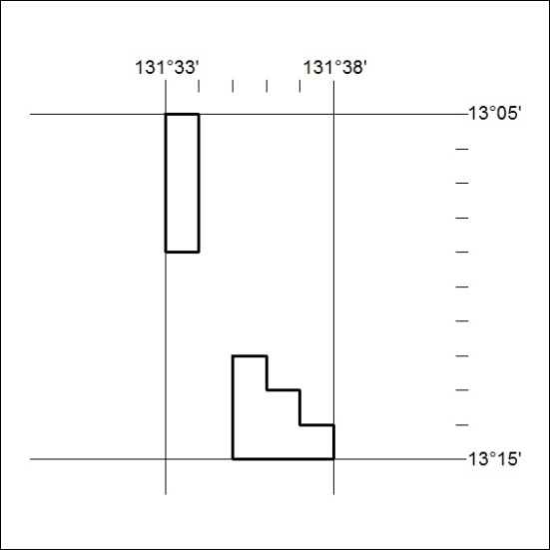

449/18

Mineral Titles Act
NOTICE OF LAND CEASING TO BE A MINERAL TITLE
Title Type and Number: | Extractive Mineral Permit 27344
Area ceased on: | 12 October 2018
Area: | 45.00 Hectare
Locality: | KATHERINE
Name of Applicants(s)Holder(s): | 100% SUFFREN CONTRACTING & PLANT HIRE PTY LTD [ACN. 084 267 596]
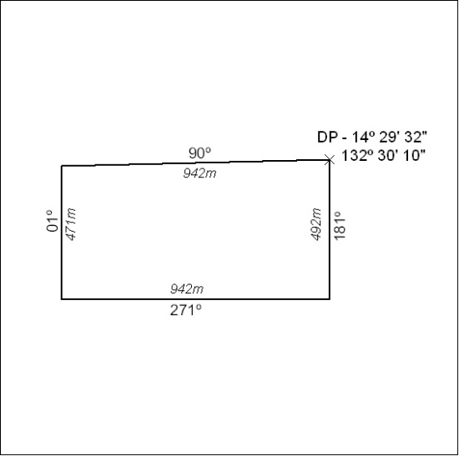

450/18

