Mineral Titles Act
NOTICE OF LAND CEASING TO BE A MINERAL TITLE
Title Type and Number: | Extractive Mineral Lease 29971
Area ceased on: | 15 January 2019
Area: | 65.00 Hectare
Locality: | NOONAMAH
Name of Applicants(s)Holder(s): | 100% A AND SF MADDALOZZO PTY. LIMITED [ACN. 009 624 015]
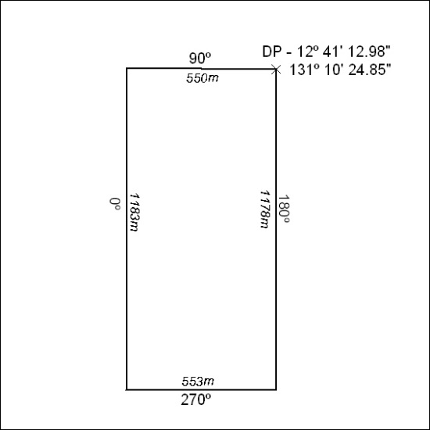

07/19

Mineral Titles Act
NOTICE OF LAND CEASING TO BE A MINERAL TITLE
Title Type and Number: | Extractive Mineral Lease 29972
Area ceased on: | 15 January 2019
Area: | 30.00 Hectare
Locality: | NOONAMAH
Name of Applicants(s)Holder(s): | 100% A AND SF MADDALOZZO PTY. LIMITED [ACN. 009 624 015]
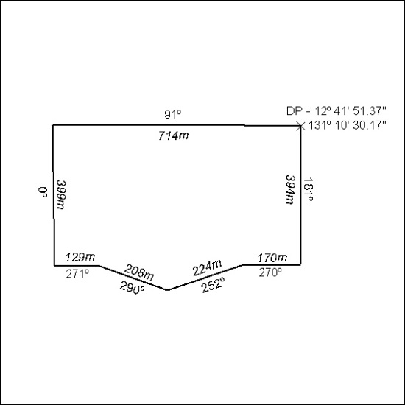

08/19

Mineral Titles Act
NOTICE OF LAND CEASING TO BE A MINERAL TITLE
Title Type and Number: | Extractive Mineral Lease 29973
Area ceased on: | 15 January 2019
Area: | 87.00 Hectare
Locality: | NOONAMAH
Name of Applicants(s)Holder(s): | 100% A AND SF MADDALOZZO PTY. LIMITED [ACN. 009 624 015]
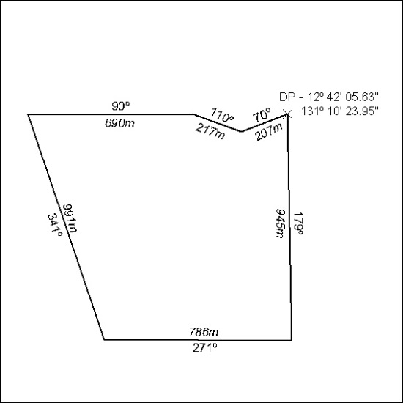

09/19

