Mineral Titles Act
NOTICE OF LAND CEASING TO BE A MINERAL TITLE AREA
Title Type and Number: | Exploration Licence 25430
Area Ceased on: | 13 March 2019
Area: | 13 Blocks, 32.37 km²
Locality: | RIDDOCH
Name of Applicant(s)/Holder(s): | 100% BARFUSS CORPORATION PTY. LTD. [ACN. 006 917 666]
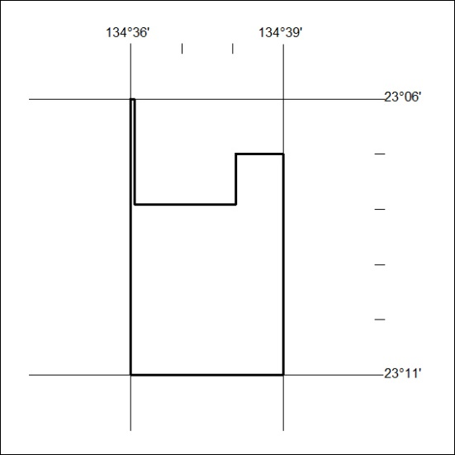

86/19

Mineral Titles Act
NOTICE OF GRANT OF A MINERAL TITLE
Title Type and Number: | Exploration Licence 31960
Granted: | 12 March 2019, for a period of 6 Years
Area: | 21 Blocks, 69.95 km²
Locality: | RANFORD HILL
Name of Holder/s: | 100% TRAFALGAR RESOURCES PTY LTD [ACN. 612 053 166]
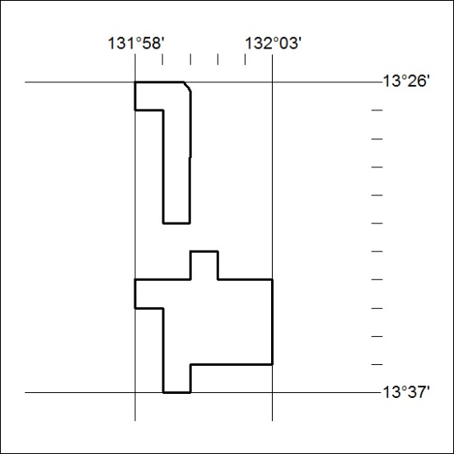
Area granted is indicated above. The titleholder is not permitted to exercise occupational rights on any land that is subject to a development title, or an application for a development title. Any land the subject of a Reserved Land gazettal under the Mineral Titles Act and all land vested in the Commonwealth of Australia is also excluded by description but not excised from the grant area.

87/19

