Mineral Titles Act 2010
NOTICE OF LAND CEASING TO BE A MINERAL TITLE AREA
Title Type and Number: | Exploration Licence 31820
Area Ceased on: | 29 March 2019
Area: | 10 Blocks, 31.78 km²
Locality: | VAUGHAN
Name of Applicant(s)/Holder(s): | 100% ENERGY METALS LTD [ACN. 111 306 533]
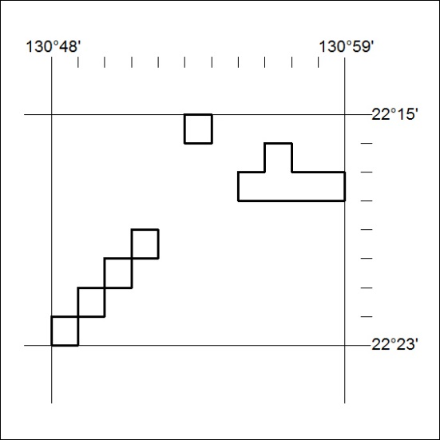

114/19

