Mineral Titles Act 2010
NOTICE OF LAND CEASING TO BE A MINERAL TITLE AREA
Title Type and Number: | Exploration Licence 24463
Area Ceased on: | 24 May 2019
Area: | 41 Blocks, 120.56 km²
Locality: | YUENDUMU
Name of Applicant(s)/Holder(s): | 100% ENERGY METALS LTD [ACN. 111 306 533]
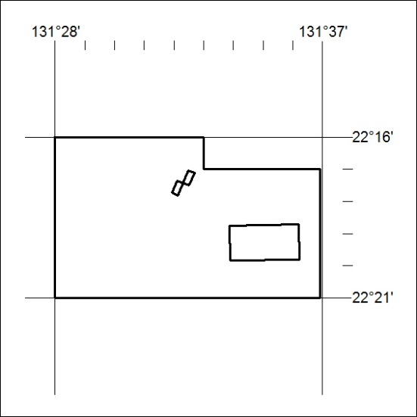
(Area now amalgamated into Exploration Licence 32113 under s102 – EL moratorium period does not apply)
201/19

Mineral Titles Act 2010
NOTICE OF LAND CEASING TO BE A MINERAL TITLE AREA
Title Type and Number: | Exploration Licence 32108
Area Ceased on: | 24 May 2019
Area: | 59 Blocks, 170.18 km²
Locality: | DOREEN
Name of Applicant(s)/Holder(s): | 100% ENERGY METALS LTD  [ACN. 111 306 533]
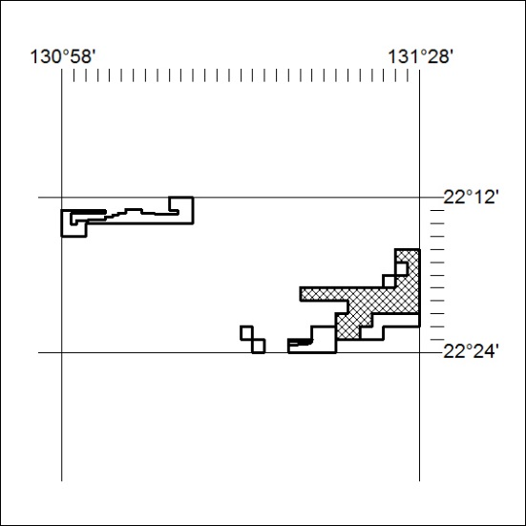
(Hatched area now amalgamated into Exploration Licence 32113 under s102 – EL moratorium period does not apply to this area)
202/19

