Mineral Titles Act 2010
NOTICE OF LAND CEASING TO BE A MINERAL TITLE AREA
Title Type and Number: | Exploration Licence 30779
Area Ceased on: | 23 September 2019
Area: | 36 Blocks, 113.81 km²
Locality: | BUSHY PARK
Name of Applicant(s)/Holder(s): | 100% TERRITORY EXPLORATION PTY LTD [ACN. 123 338 376]
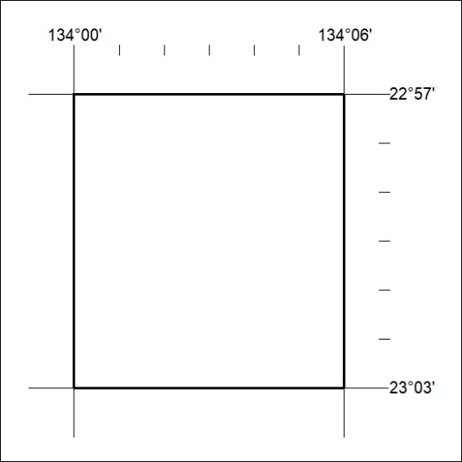

401/19

Mineral Titles Act 2010
NOTICE OF LAND CEASING TO BE A MINERAL TITLE AREA
Title Type and Number: | Extractive Mineral Exploration Licence 30895
Area Ceased on: | 21 September 2019
Area: | 4 Blocks, 11.38 km²
Locality: | KOOLPINYAH
Name of Applicant(s)/Holder(s): | 100% MOUSELLIS & SONS PTY. LTD. [ACN. 009 654 791]
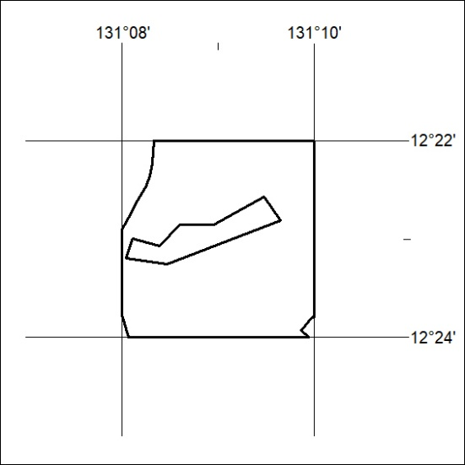

402/19
Mineral Titles Act 2010
NOTICE OF LAND CEASING TO BE A MINERAL TITLE AREA
Title Type and Number: | Extractive Mineral Exploration Licence 31068
Area Ceased on: | 21 September 2019
Area: | 5 Blocks, 9.93 km²
Locality: | KOOLPINYAH
Name of Applicant(s)/Holder(s): | 100% MOUSELLIS & SONS PTY. LTD. [ACN. 009 654 791]
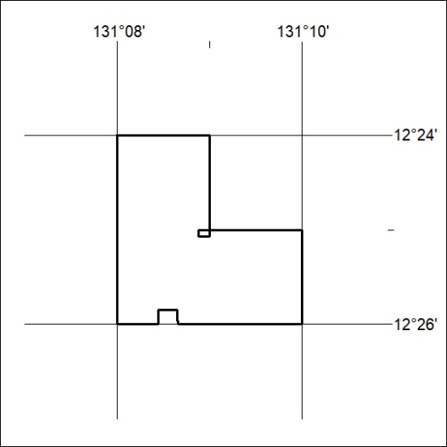

402/19

