Mineral Titles Act 2010
NOTICE OF LAND CEASING TO BE A MINERAL TITLE AREA
Title Type and Number: | Exploration Licence 31641
Area Ceased on: | 28 January 2020
Area: | 7 Blocks, 22.17 km²
Locality: | MT WEDGE
Name of Applicant(s)/Holder(s): | 100% MIOXIDE NT PTY LTD [ACN. 636 686 747]
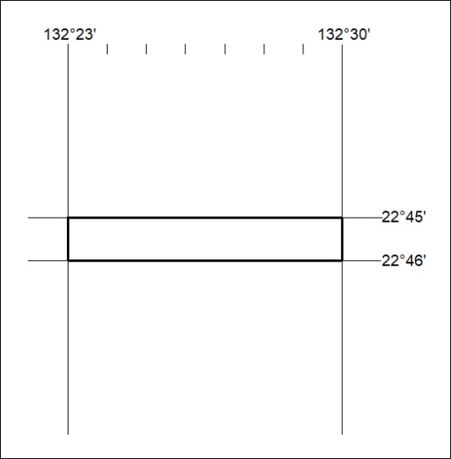
(Area now amalgamated into Exploration Licence 32357 under s102 – EL moratorium period does not apply)

49/20

Mineral Titles Act 2010
NOTICE OF LAND CEASING TO BE A MINERAL TITLE AREA
Title Type and Number: | Exploration Licence 32090
Area Ceased on: | 28 January 2020
Area: | 9 Blocks, 28.50 km²
Locality: | NAPPERBY
Name of Applicant(s)/Holder(s): | 100% MIOXIDE NT PTY LTD [ACN. 636 686 747]
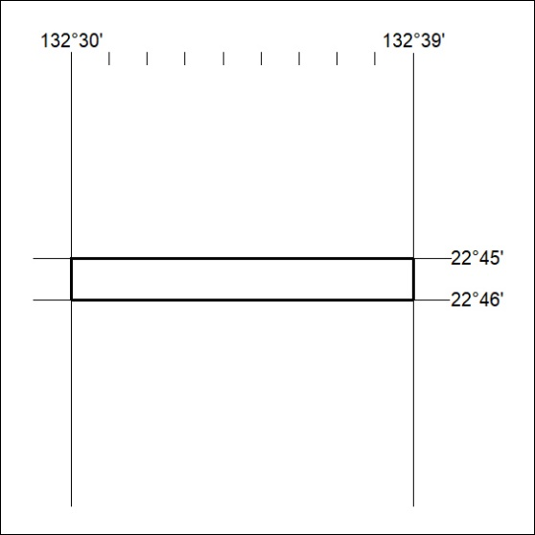
(Area now amalgamated into Exploration Licence 32357 under s102 – EL moratorium period does not apply)

50/20

Mineral Titles Act
NOTICE OF GRANT OF A MINERAL TITLE
Title Type and Number: | Exploration Licence 32200
Granted: | 31 January 2020, for a period of 6 Years
Area: | 4 Blocks, 12.86 km²
Locality: | DAVENPORT RANGE
Name of Holder/s: | 100% TREASURE CREEK PTY LTD [ACN. 619 057 644]
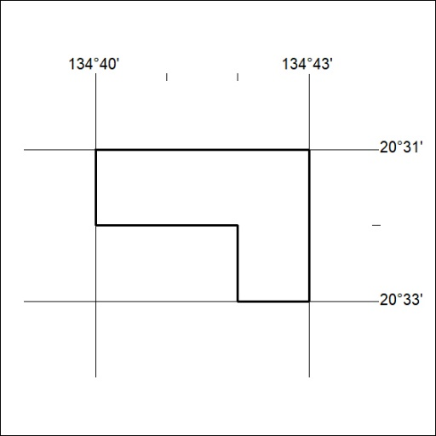
Area granted is indicated above. The titleholder is not permitted to exercise occupational rights on any land that is subject to a development title, or an application for a development title. Any land the subject of a Reserved Land gazettal under the Mineral Titles Act and all land vested in the Commonwealth of Australia is also excluded by description but not excised from the grant area.

51/20

Mineral Titles Act
NOTICE OF GRANT OF A MINERAL TITLE
Title Type and Number: | Exploration Licence 32199
Granted: | 31 January 2020, for a period of 6 Years
Area: | 59 Blocks, 178.20 km²
Locality: | DAVENPORT RANGE
Name of Holder/s: | 100% TREASURE CREEK PTY LTD [ACN. 619 057 644]
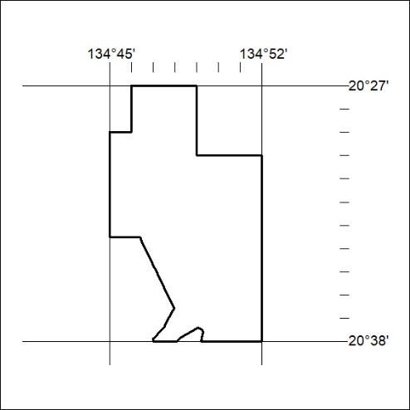
Area granted is indicated above. The titleholder is not permitted to exercise occupational rights on any land that is subject to a development title, or an application for a development title. Any land the subject of a Reserved Land gazettal under the Mineral Titles Act and all land vested in the Commonwealth of Australia is also excluded by description but not excised from the grant area.

52/20

