Mineral Titles Act 2010
NOTICE OF LAND CEASING TO BE A MINERAL TITLE AREA
Title Type and Number: | Mineral Lease (Northern) 24
Area ceased on: | 27 February 2020
Area: | 31.00 Hectare
Locality: | STOW
Name of Applicants(s)Holder(s): | 100% NEWCREST OPERATIONS LIMITED [ACN. 009 221 505]
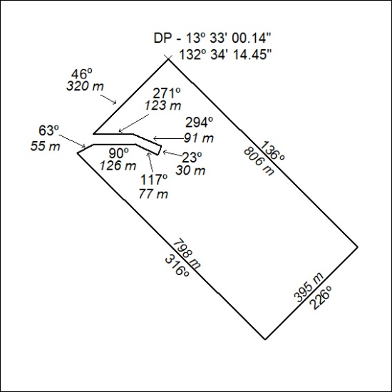

117/20

Mineral Titles Act 2010
NOTICE OF LAND CEASING TO BE A MINERAL TITLE AREA
Title Type and Number: | Exploration Licence 28237
Area Ceased on: | 28 February 2020
Area: | 7 Blocks, 21.96 km²
Locality: | DAVENPORT RANGE
Name of Applicant(s)/Holder(s): | 100% AUSTRALIA MINING & GEMSTONE CO. PTY LTD [ACN. 114 395 247]
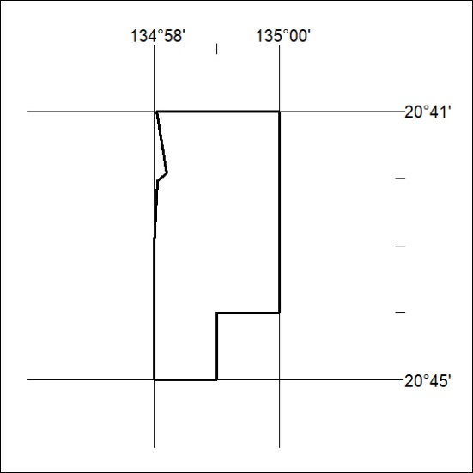

118/20
Mineral Titles Act 2010
NOTICE OF LAND CEASING TO BE A MINERAL TITLE AREA
Title Type and Number: | Exploration Licence 28238
Area Ceased on: | 28 February 2020
Area: | 7 Blocks, 21.23 km²
Locality: | HATCHES
Name of Applicant(s)/Holder(s): | 100% AUSTRALIA MINING & GEMSTONE CO. PTY LTD [ACN. 114 395 247]
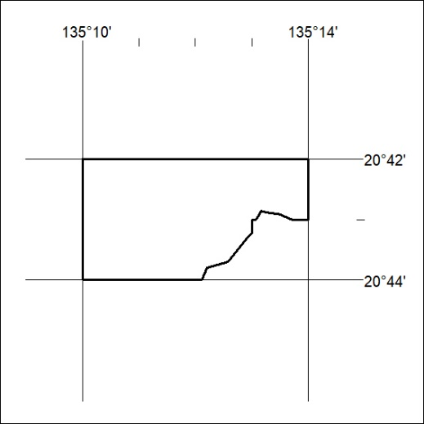

119/20

