Mineral Titles Act 2010
NOTICE OF LAND CEASING TO BE A MINERAL TITLE AREA
Title Type and Number: | Exploration Licence 25581
Area Ceased on: | 16 April 2020
Area: | 100 Blocks, 306.18 km²
Locality: | CHALUBA
Name of Applicant(s)/Holder(s): | 100% TODD RIVER METALS PTY LTD [ACN. 600 314 038]
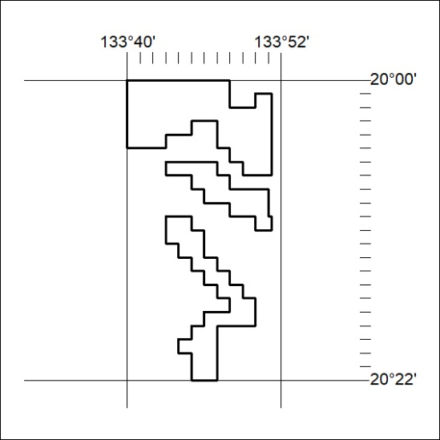
165/20

Mineral Titles Act 2010
NOTICE OF LAND CEASING TO BE A MINERAL TITLE AREA
Title Type and Number: | Exploration Licence 29793
Area Ceased on: | 16 April 2020
Area: | 47 Blocks, 152.74 km²
Locality: | MITCHIEBO
Name of Applicant(s)/Holder(s): | 100% TECK AUSTRALIA PTY LTD [ACN. 091 271 911]
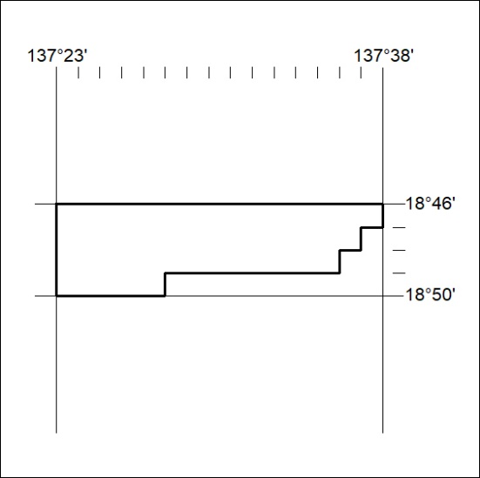
166/20

Mineral Titles Act 2010
NOTICE OF LAND CEASING TO BE A MINERAL TITLE AREA
Title Type and Number: | Exploration Licence 29794
Area Ceased on: | 16 April 2020
Area: | 48 Blocks, 156.16 km²
Locality: | MITCHIEBO
Name of Applicant(s)/Holder(s): | 100% TECK AUSTRALIA PTY LTD [ACN. 091 271 911]
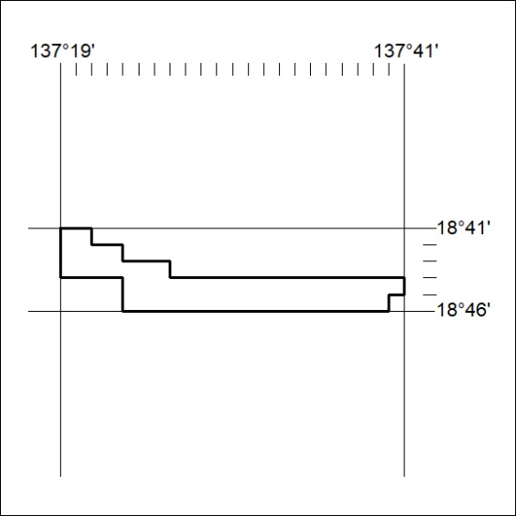
167/20

Mineral Titles Act 2010
NOTICE OF LAND CEASING TO BE A MINERAL TITLE AREA
Title Type and Number: | Exploration Licence 30665
Area Ceased on: | 16 April 2020
Area: | 30 Blocks, 97.55 km²
Locality: | MITCHIEBO
Name of Applicant(s)/Holder(s): | 100% TECK AUSTRALIA PTY LTD [ACN. 091 271 911]
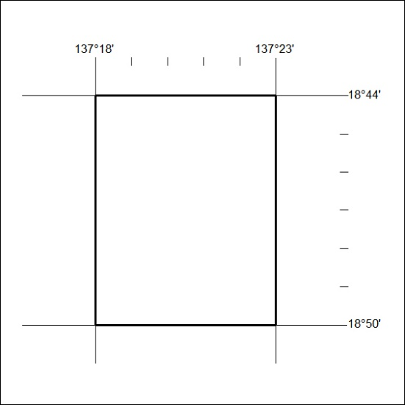
168/20

