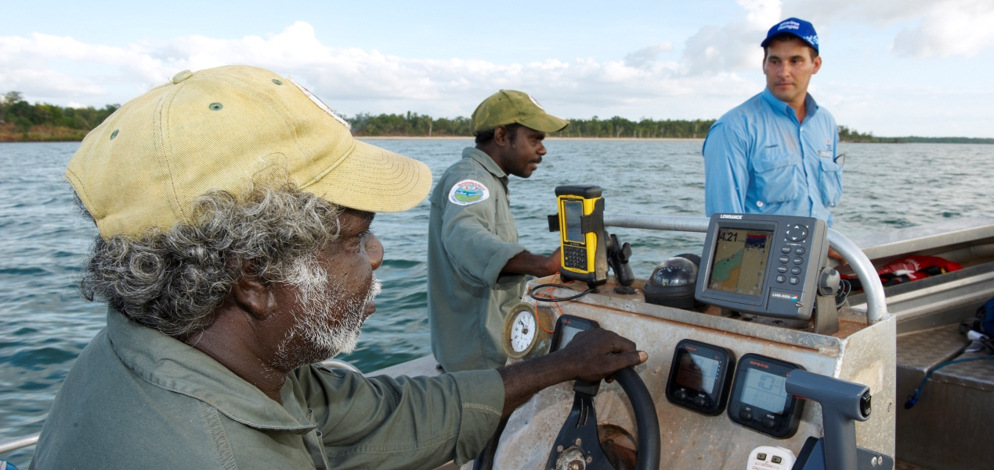

Background
As the NT coastline spans some 10,000 kilometres, the challenges faced by government agencies in maintaining an effective and timely surveillance and deterrence capability are significant. It is therefore imperative to work with Aboriginal ranger groups to enhance government’s coastal monitoring capability.
Currently there are already 16 established Marine/Sea Ranger groups distributed along most of the NT coastline. With respect to land adjoining NT coastal waters, approximately 71.5% of the mainland coastline and 92% of the island coastline has been declared Aboriginal land down to the low water mark [under the Commonwealth’s Aboriginal Land Rights (Northern Territory) Act 1976]. The waters to the low water mark are also recognised as exclusively controlled access by Aboriginal people since the High Court’s decision on Blue Mud Bay.
Given the existing distribution of these groups along the NT coastline; their intimate knowledge of remote coastal areas; level of relevant training; and the types of monitoring and surveillance activities already undertaken, Marine/Sea Rangers are ideally placed to assist government agencies monitor coastal waters.
In most cases the overseeing and funding of Aboriginal ranger activities is variously provided by the Tiwi Land Council, the Northern Land Council and the Anindilyakwa Land Council; much of which is funded through the Commonwealth Government’s ‘Caring For Our Country’ program.

The NT Fisheries Division (Department of Resources) currently provides funding assistance to eight ranger groups under the auspices of the Indigenous Community Marine Ranger Program (ICMRP). The following Marine/Sea Ranger groups are being supported under the ICMRP:

- Tiwi Marine Rangers (Tiwi Islands);
- Li-Anthawirriyarra Sea Rangers (Borroloola);
- Thamarrurr Rangers (Port Keats);
- Djelk Sea Rangers (Maningrida);
- Mardbalk Sea Rangers (Warruwi);
- Yugul Mangi Land and Sea Rangers (Ngukurr);
- Anindilyakwa Sea Rangers (Groote Eylandt); and,
- Gumurr Marthakal Sea Rangers (Elcho Island).
Marine/Sea Rangers assist with local monitoring and surveillance of coastal waters, as well as providing a visual presence on the water. Increasingly, Marine/Sea Rangers play an important role in educating both Indigenous and non-Indigenous fishers.
The types of activities routinely undertaken by Marine Rangers, as well as the nature of information reported by these groups, are outlined below.

Surveillance
Reports are provided to Fisheries and other government agencies on the following:
- Any illegal activities either witnessed or suspected.
- Suspicious vessels, vehicles, aircraft or persons operating in local areas or in prohibited or closed areas.
- Any illegal Foreign Fishing Vessels in local waters and/or any shore landings of illegal persons.
- The presence of spotlights, small vessels or sounds of outboard motors operating in creeks at night.
- Nets, crab pots or other fishing equipment which are illegally set or unmarked.
- Catches of aquatic life in excess of bag limits.
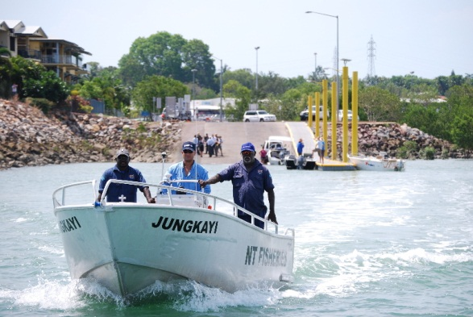
- Fish or other aquatic life being sold or offered at cheap rates.

Reporting of sea management activities
- The presence of dead fish either floating or washed ashore.
- Details and/or samples of suspicious or unknown marine species (e.g. aquatic pests) located in unusual areas or in increasing numbers.
- Information on fishing patterns and the loss or return of aquatic species (e.g. fish, dugong, turtles etc.) in their patrol areas.
- Any dead, sick or injured dugong, crocodiles or turtles.
- Marine debris (e.g. ghost nets etc).

Education and other activities
- Information provided to the public on fisheries regulations and policies;
- Information and education sessions provided to schools or other community groups;
- Requirements for any additional education materials for distribution;
- Reports to relevant forums such as Aboriginal Coastal Consultative Committees or similar type committees.
From a Northern Territory Government perspective, Marine/Sea Ranger groups add value to the monitoring and protection of coastal habitats in remote areas through:
- Supporting the policing and deterrence of illegal activities through increased surveillance;
- Assisting government when dealing with marine issues involving Indigenous people;
- Provision of assistance in marine search and rescue activities;
- Promotion and leadership of marine safety in remote communities;
- Providing a more frequent and locally experienced presence when undertaking surveillance activities; and
- Linking into Indigenous networks of information sharing.
- Undertaking monitoring and research activities to ensure health of fishstocks.

Training for Marine/Sea Rangers
Since 2009 some 72 Marine/Sea Rangers have successfully completed a Certificate II Fisheries Compliance (Seafood Industry) course. This training has been developed and delivered by NT Fisheries, NT Water Police and Charles Darwin University. (Download 2010 Report)
Components of the current training provided to rangers include:
- Fisheries compliance;
- Report writing and evidence gathering for court room settings;
- Occupational Safety and Health at sea;
- Techniques for the monitoring of marine resources;
- Liaison techniques when dealing with fishermen; and

Government Coordination
Crucial to the effectiveness of Marine/Sea Rangers is the coordination of activities with respect to coastal surveillance on behalf of government agencies. As such, a Marine Ranger Coordinator position has been created within the NT Fisheries Division to undertake this role, and to assist Ranger groups to maintain their operational readiness. The key activities undertaken by this position are listed below.
- Work with the Commonwealth and Territory governments agencies, land councils, local community organisations and Marine/Sea Ranger groups to develop, implement and evaluate service level agreements for coastal surveillance activities.
- Liaise with all relevant agencies and groups to establish protocols and lines of communication for the reporting of fishing activities.
- Assist Marine/Sea Ranger groups with the procurement of resources and equipment to undertake monitoring and surveillance operations.
- Assist Marine/Sea Ranger groups to maintain their operational readiness.
- Coordinate the training requirements for Marine/Sea Rangers.
- Maintain records with respect to coastal surveillance activities undertaken by Marine Ranger groups.

Achievements

Participation in research
Fisheries Division undertakes field work and ‘joint’ research activities with many of the Marine/Sea ranger groups across the NT. Some of the achievements to date include:
- Installation of the Blyth River marine sacred site buoyage system;
- Juvenile mud crab research with four coastal ranger groups;
- Juvenile and Mature snapper research with fisheries research and costal ranger groups;
- Shark and Stingray Indigenous fishing survey with Anindilyakwa Sea Rangers of Groote Eylandt;
- Ranger intelligence leading to four convictions for breaches to the Fisheries Act and Sacred Sites Act;
- Winner of the Northern Territory Seafood Industry training award 2009 and 2011;
- Winner of the 2011 Chief Ministers Awards for Excellence in the Public Sector, Delivering Quality Education and Training category
- Winner of the 5th Australian Seafood Industry training award 2010; and
- A number of seized vessels and vehicles have been “gifted” providing additional resources to rangers.
In recognition of the increasing engagement of Marine/Sea Rangers in fisheries related activities, Fisheries Division has recently developed its own Marine/Sea Ranger engagement policy. It is intended that this policy will provide clear guidelines for Fisheries staff that intend on working with Marine/Sea Rangers.

