Mineral Titles Act
NOTICE OF LAND CEASING TO BE A MINERAL TITLE AREA
Title Type and Number: | Exploration Licence 28844
Area Ceased on: | 05 March 2018
Area: | 2 Blocks, 6.59 km²
Locality: | HUMBERT
Name of Applicant(s)/Holder(s): | 100% AUSTRALIA MINING & GEMSTONE CO. PTY LTD [ACN. 114 395 247]
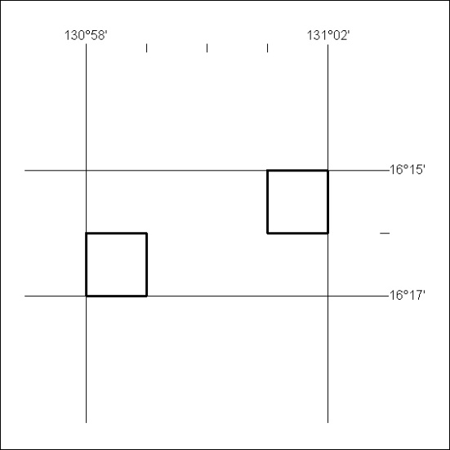
90/18

Mineral Titles Act
NOTICE OF LAND CEASING TO BE A MINERAL TITLE AREA
Title Type and Number: | Exploration Licence 28850
Area Ceased on: | 05 March 2018
Area: | 4 Blocks, 13.17 km²
Locality: | HUMBERT
Name of Applicant(s)/Holder(s): | 100% AUSTRALIA MINING & GEMSTONE CO. PTY LTD [ACN. 114 395 247]
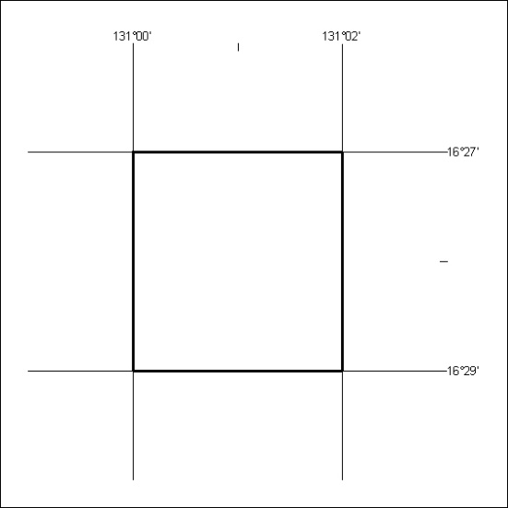
91/18

Mineral Titles Act
NOTICE OF LAND CEASING TO BE A MINERAL TITLE AREA
Title Type and Number: | Exploration Licence 28944
Area Ceased on: | 05 March 2018
Area: | 5 Blocks, 15.80 km²
Locality: | AILERON
Name of Applicant(s)/Holder(s): | 100% AUSTRALIA MINING & GEMSTONE CO. PTY LTD [ACN. 114 395 247]
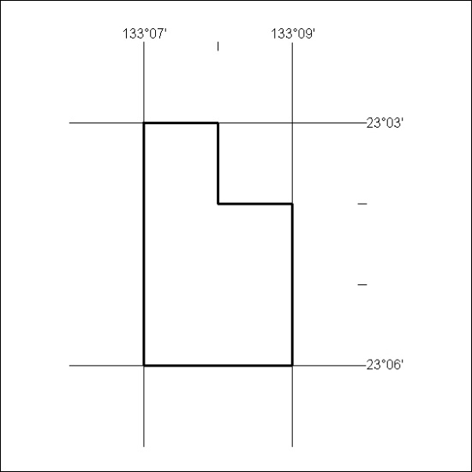
92/18

Mineral Titles Act
NOTICE OF LAND CEASING TO BE A MINERAL TITLE AREA
Title Type and Number: | Exploration Licence 28945
Area Ceased on: | 05 March 2018
Area: | 5 Blocks, 15.84 km²
Locality: | AILERON
Name of Applicant(s)/Holder(s): | 100% AUSTRALIA MINING & GEMSTONE CO. PTY LTD [ACN. 114 395 247]
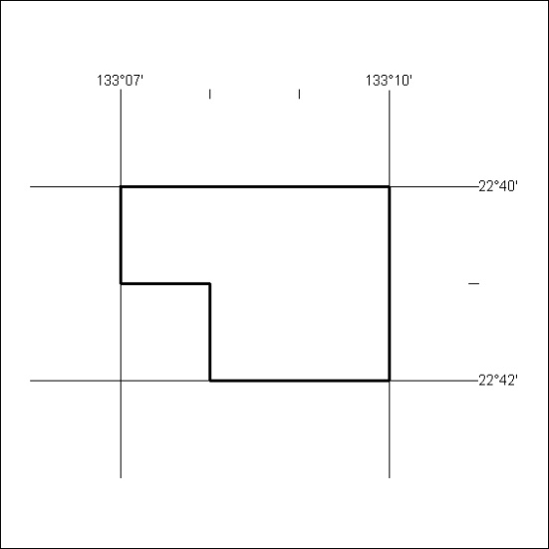
93/18

Mineral Titles Act
NOTICE OF LAND CEASING TO BE A MINERAL TITLE AREA
Title Type and Number: | Exploration Licence 29748
Area Ceased on: | 28 February 2018
Area: | 218 Blocks, 671.24 km²
Locality: | LEISLER
Name of Applicant(s)/Holder(s): | 100% CASTILE RESOURCES PTY LTD [ACN. 124 314 085]
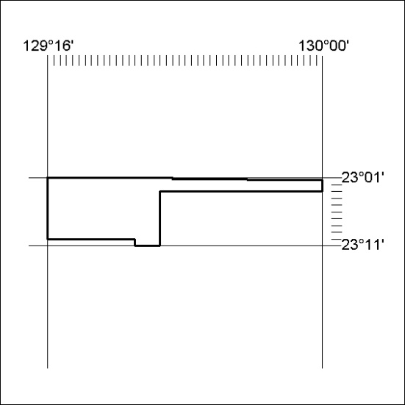
(Area now amalgamated into Exploration Licence 31794 under s102 – EL moratorium period does not apply)
94/18

Mineral Titles Act
NOTICE OF LAND CEASING TO BE A MINERAL TITLE AREA
Title Type and Number: | Exploration Licence 31606
Area Ceased on: | 28 February 2018
Area: | 24 Blocks, 17.52 km²
Locality: | WILLIE
Name of Applicant(s)/Holder(s): | 100% CASTILE RESOURCES PTY LTD [ACN. 124 314 085]
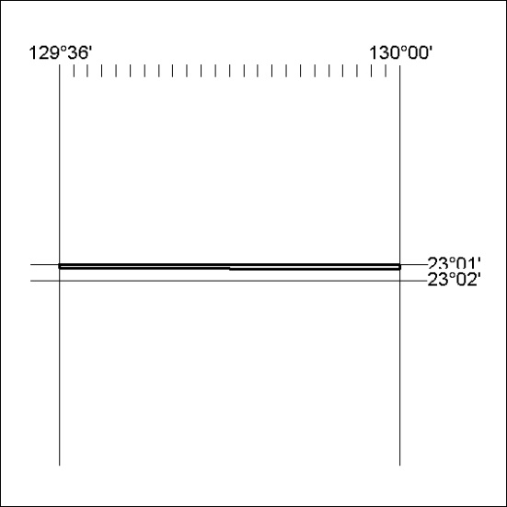

(Area now amalgamated into Exploration Licence 31794 under s102 – EL moratorium period does not apply)
95/18

Mineral Titles Act
NOTICE OF LAND CEASING TO BE A MINERAL TITLE
Title Type and Number: | Extractive Mineral Permit 29821
Area ceased on: | 05 March 2018
Area: | 84.00 Hectare
Locality: | ALICE SPRINGS
Name of Applicants(s)Holder(s): | 100% NORTH CONCRETE (NT) PTY LTD [ACN. 128 802 997]
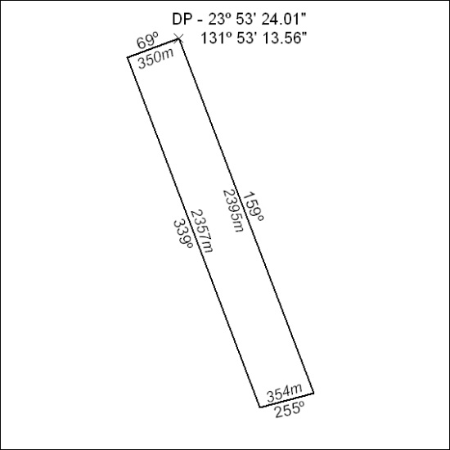
96/18

Mineral Titles Act
NOTICE OF GRANT OF A MINERAL TITLE
Title Type and Number: | Extractive Mineral Exploration Licence 31593
Granted: | 01 March 2018, for a period of 2 Years
Area: | 4 Blocks, 13.35 km²
Locality: | PINE CREEK
Name of Holder/s: | 100% JN. MOUSELLIS CIVIL CONTRACTORS PTY LTD [ACN. 122 603 990]
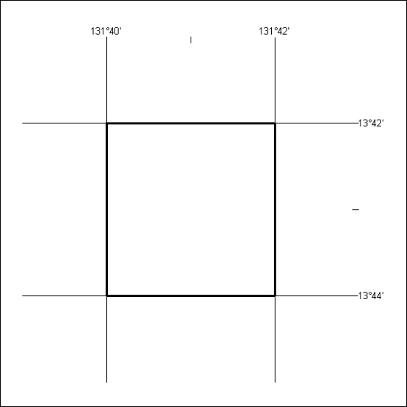
Area granted is indicated above. The titleholder is not permitted to exercise occupational rights on any land that is subject to a development title, or an application for a development title. Any land the subject of a Reserved Land gazettal under the Mineral Titles Act and all land vested in the Commonwealth of Australia is also excluded by description but not excised from the grant area.
97/18

Mineral Titles Act
NOTICE OF GRANT OF A MINERAL TITLE
Title Type and Number: | Extractive Mineral Exploration Licence 31594
Granted: | 01 March 2018, for a period of 2 Years
Area: | 3 Blocks, 10.01 km²
Locality: | PINE CREEK
Name of Holder/s: | 100% JN. MOUSELLIS CIVIL CONTRACTORS PTY LTD [ACN. 122 603 990]
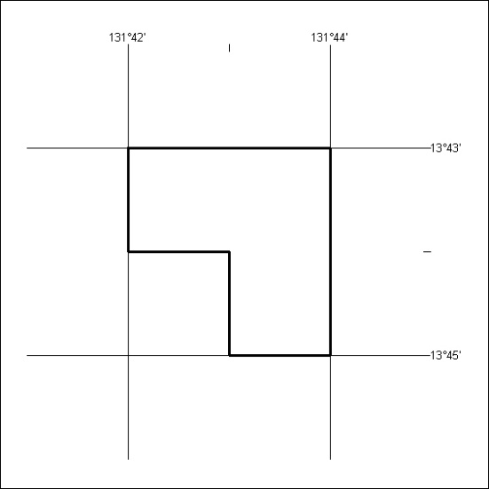
Area granted is indicated above. The titleholder is not permitted to exercise occupational rights on any land that is subject to a development title, or an application for a development title. Any land the subject of a Reserved Land gazettal under the Mineral Titles Act and all land vested in the Commonwealth of Australia is also excluded by description but not excised from the grant area.
98/18

