Mineral Titles Act
NOTICE OF LAND CEASING TO BE A MINERAL TITLE
Title Type and Number: | Extractive Mineral Permit 22484
Area ceased on: | 13 May 2018
Area: | 4.00 Hectare
Locality: | KOOLPINYAH
Name of Applicants(s)Holder(s): | 100% HUTCHINSON William David
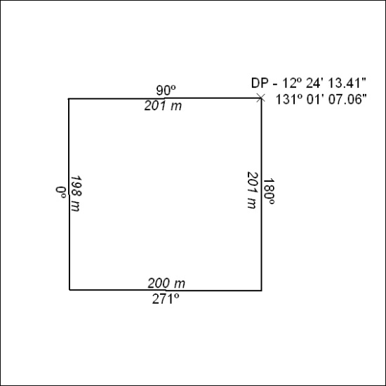

182/18

Mineral Titles Act
NOTICE OF LAND CEASING TO BE A MINERAL TITLE
Title Type and Number: | Extractive Mineral Permit 22485
Area ceased on: | 13 May 2018
Area: | 6.00 Hectare
Locality: | KOOLPINYAH
Name of Applicants(s)Holder(s): | 100% HUTCHINSON William David
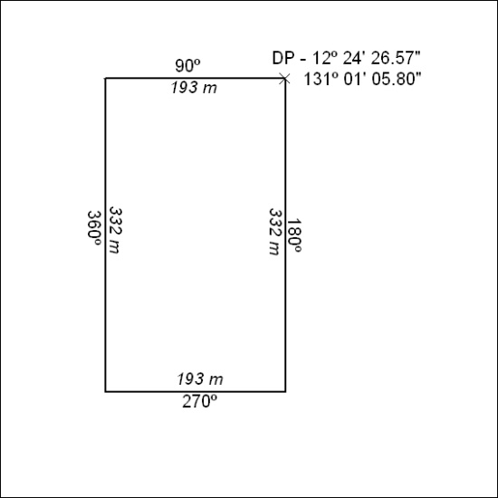

183/18

Mineral Titles Act
NOTICE OF LAND CEASING TO BE A MINERAL TITLE AREA
Title Type and Number: | Exploration Licence 31811
Area Ceased on: | 15 May 2018
Area: | 249 Blocks, 825.95 km²
Locality: | MATARANKA
Name of Applicant(s)/Holder(s): | 100% MMG EXPLORATION PTY LTD* [ACN. 119 136 659]
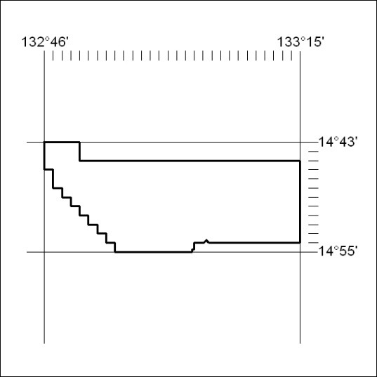

184/18

