Mineral Titles Act
NOTICE OF LAND CEASING TO BE A MINERAL TITLE
Title Type and Number: | Extractive Mineral Permit 28655
Area ceased on: | 12 October 2018
Area: | 61.00 Hectare
Locality: | NOONAMAH
Name of Applicants(s)Holder(s): | 100% KIGILIA PTY LTD [ACN. 113 822 343]
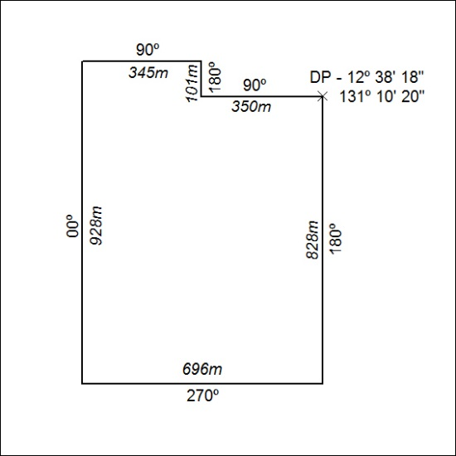

457/18

5Mineral Titles Act
NOTICE OF LAND CEASING TO BE A MINERAL TITLE
Title Type and Number: | Extractive Mineral Permit 30685
Area ceased on: | 18 October 2018
Area: | 5.82 Hectare
Locality: | NOONAMAH
Name of Applicants(s)Holder(s): | 100% OSTOJIC GROUP PTY LTD* [ACN. 009 629 805]
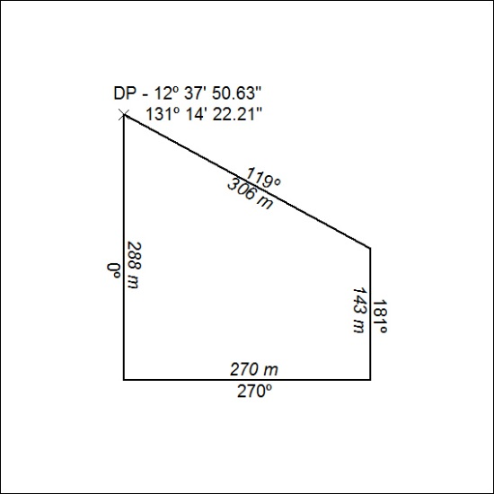

458/18

