Mineral Titles Act 2010
NOTICE OF LAND CEASING TO BE A MINERAL TITLE AREA
Title Type and Number: | Exploration Licence 27417
Area Ceased on: | 13 January 2020
Area: | 12 Blocks, 37.13 km²
Locality: | SENTINEL BORE
Name of Applicant(s)/Holder(s): | 100% GLOBE MINERAL RESOURCES INVESTMENTS PTY LTD [ACN. 147 814 140]
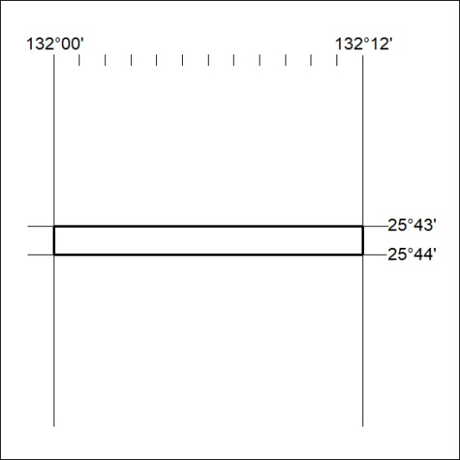

16/20

Mineral Titles Act 2010
NOTICE OF LAND CEASING TO BE A MINERAL TITLE AREA
Title Type and Number: | Exploration Licence 27418
Area Ceased on: | 13 January 2020
Area: | 184 Blocks, 566.57 km²
Locality: | SENTINEL BORE
Name of Applicant(s)/Holder(s): | 100% GLOBE MINERAL RESOURCES INVESTMENTS PTY LTD [ACN. 147 814 140]
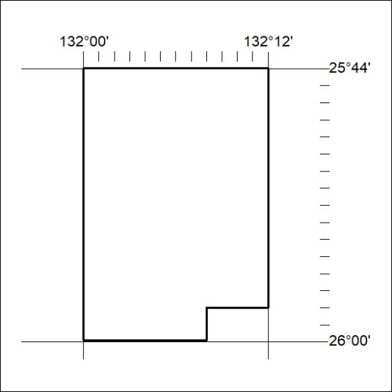

17/20
Mineral Titles Act 2010
NOTICE OF LAND CEASING TO BE A MINERAL TITLE AREA
Title Type and Number: | Exploration Licence 27419
Area Ceased on: | 13 January 2020
Area: | 10 Blocks, 30.91 km²
Locality: | SENTINEL BORE
Name of Applicant(s)/Holder(s): | 100% GLOBE MINERAL RESOURCES INVESTMENTS PTY LTD [ACN. 147 814 140]
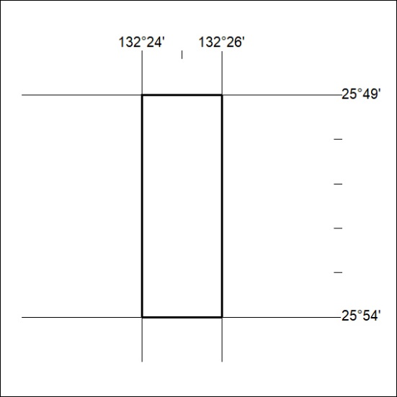

18/20

