Mineral Titles Act
NOTICE OF LAND CEASING TO BE A MINERAL TITLE AREA
Title Type and Number: | Extractive Mineral Exploration Licence 30880
Area Ceased on: | 19 June 2018
Area: | 2 Blocks, 6.70 km²
Locality: | MARY RIVER
Name of Applicant(s)/Holder(s): | 100% BORAL RESOURCES (WA) LTD [ACN. 008 686 904]
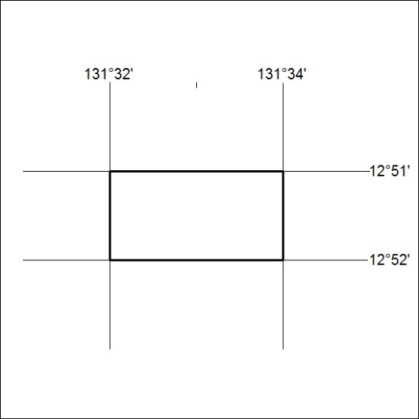

274/18

Mineral Titles Act
NOTICE OF GRANT OF A MINERAL TITLE
Title Type and Number: | Exploration Licence 31624
Granted: | 18 June 2018, for a period of 6 Years
Area: | 41 Blocks, 132.05 km²
Locality: | OORADIDGEE
Name of Holder/s: | 100% TREASURE CREEK PTY LTD [ACN. 619 057 644]
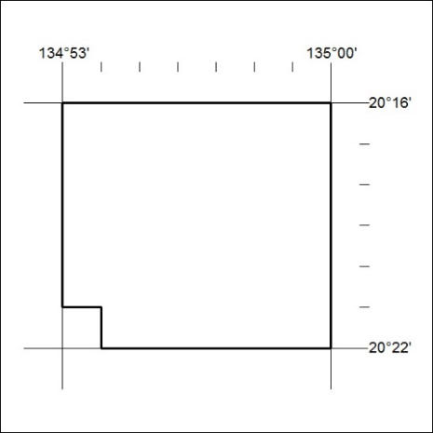
Area granted is indicated above. The titleholder is not permitted to exercise occupational rights on any land that is subject to a development title, or an application for a development title. Any land the subject of a Reserved Land gazettal under the Mineral Titles Act and all land vested in the Commonwealth of Australia is also excluded by description but not excised from the grant area.

275/18

Mineral Titles Act
NOTICE OF GRANT OF A MINERAL TITLE
Title Type and Number: | Exploration Licence 31626
Granted: | 18 June 2018, for a period of 6 Years
Area: | 184 Blocks, 591.73 km²
Locality: | OORADIDGEE
Name of Holder/s: | 100% TREASURE CREEK PTY LTD [ACN. 619 057 644]
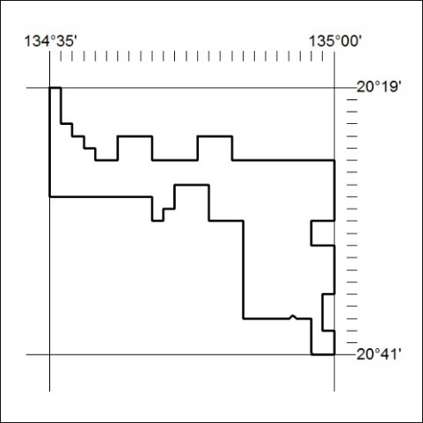
Area granted is indicated above. The titleholder is not permitted to exercise occupational rights on any land that is subject to a development title, or an application for a development title. Any land the subject of a Reserved Land gazettal under the Mineral Titles Act and all land vested in the Commonwealth of Australia is also excluded by description but not excised from the grant area.

276/18

