Mineral Titles Act 2010
NOTICE OF LAND CEASING TO BE A MINERAL TITLE AREA
Title Type and Number: | Exploration Licence 26094
Area Ceased on: | 05 May 2020
Area: | 12 Blocks, 24.40 km²
Locality: | NOONAMAH
Name of Applicant(s)/Holder(s): | 100% PODIUM MINERALS LIMITED [ACN. 009 200 079]
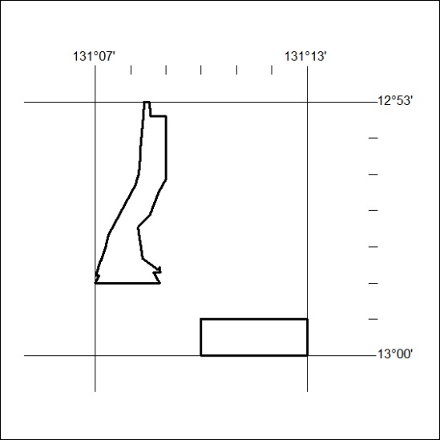
177/20

Mineral Titles Act 2010
NOTICE OF LAND CEASING TO BE A MINERAL TITLE AREA
Title Type and Number: | Exploration Licence 27266
Area Ceased on: | 06 May 2020
Area: | 100 Blocks, 314.70 km²
Locality: | LAKE CAROLINE
Name of Applicant(s)/Holder(s): | 100% RED METAL LIMITED [ACN. 103 367 684]
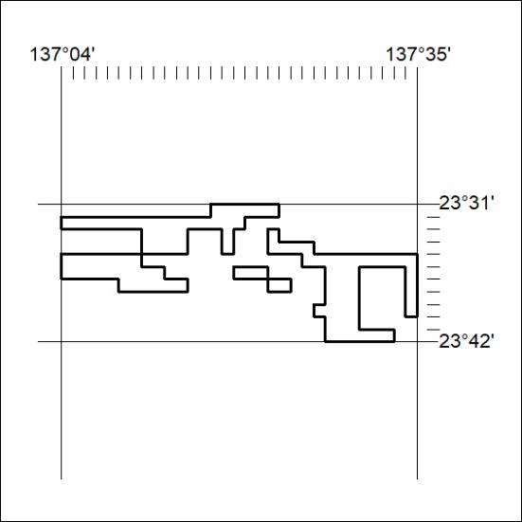
178/20

