Mineral Titles Act
NOTICE OF LAND CEASING TO BE A MINERAL TITLE
Title Type and Number: | Extractive Mineral Lease 29573
Area ceased on: | 13 June 2018
Area: | 1.00 Hectare
Locality: | NOONAMAH
Name of Applicants(s)Holder(s): | 100% BERNO BROS. PTY. LIMITED [ACN. 009 592 741]
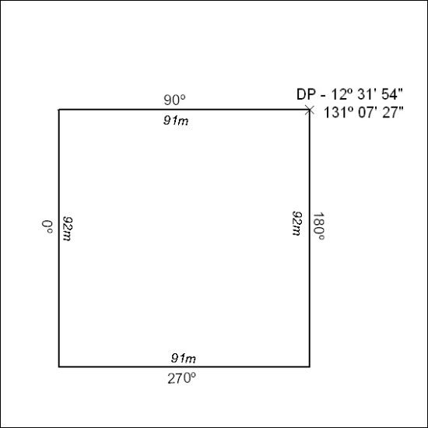

259/18

Mineral Titles Act
NOTICE OF LAND CEASING TO BE A MINERAL TITLE
Title Type and Number: | Mineral Authority 23697
Area ceased on: | 11 June 2018
Area: | 16.00 Hectare
Locality: | BYNOE
Name of Applicants(s)Holder(s): | 100% A AND SF MADDALOZZO PTY. LIMITED [ACN. 009 624 015]
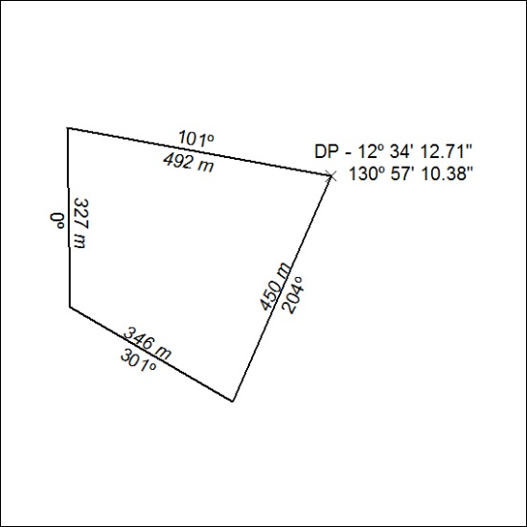

260/18

Mineral Titles Act
NOTICE OF GRANT OF A MINERAL TITLE
Title Type and Number: | Mineral Lease 29978
Granted: | 08 June 2018, for a period of 10 Years
Area: | 18.00 Hectares
Locality: | BATCHELOR
Name of Holder/s: | 100% CR & E PTY LTD [ACN. 163 015 110]
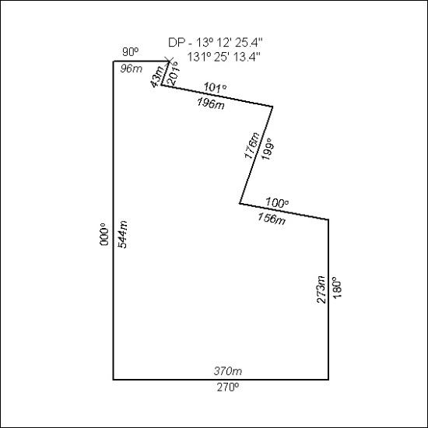

261/18

