Mineral Titles Act
NOTICE OF LAND CEASING TO BE A MINERAL TITLE
Title Type and Number: | Extractive Mineral Permit 24599
Area ceased on: | 21 December 2018
Area: | 9.00 Hectare
Locality: | NOONAMAH
Name of Applicants(s)Holder(s): | 100% BOB KERR TRANSPORT PTY LTD [ACN. 109 115 059]
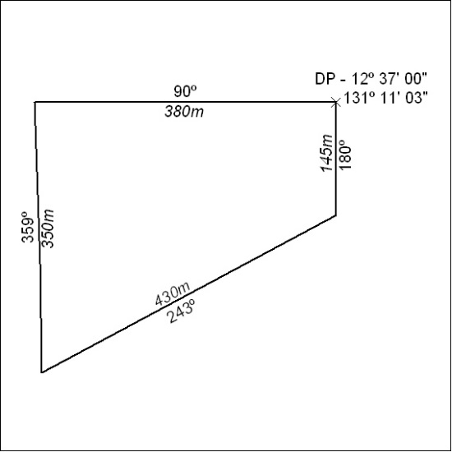

598/18

Mineral Titles Act
NOTICE OF LAND CEASING TO BE A MINERAL TITLE AREA
Title Type and Number: | Exploration Licence 30390
Area Ceased on: | 21 December 2018
Area: | 2 Blocks, 4.80 km²
Locality: | GOOMADEER
Name of Applicant(s)/Holder(s): | 100% RIO TINTO EXPLORATION PTY LIMITED [ACN. 000 057 125]
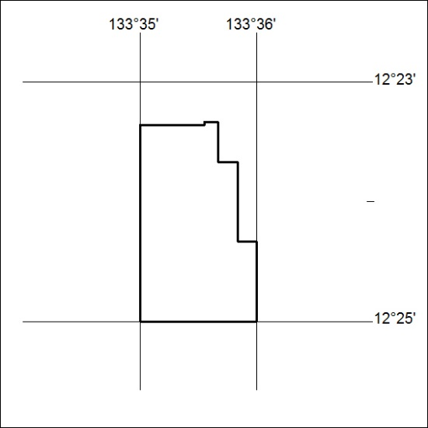

599/18

Mineral Titles Act
NOTICE OF LAND CEASING TO BE A MINERAL TITLE AREA
Title Type and Number: | Exploration Licence 30391
Area Ceased on: | 21 December 2018
Area: | 8 Blocks, 16.98 km²
Locality: | GOOMADEER
Name of Applicant(s)/Holder(s): | 100% RIO TINTO EXPLORATION PTY LIMITED [ACN. 000 057 125]
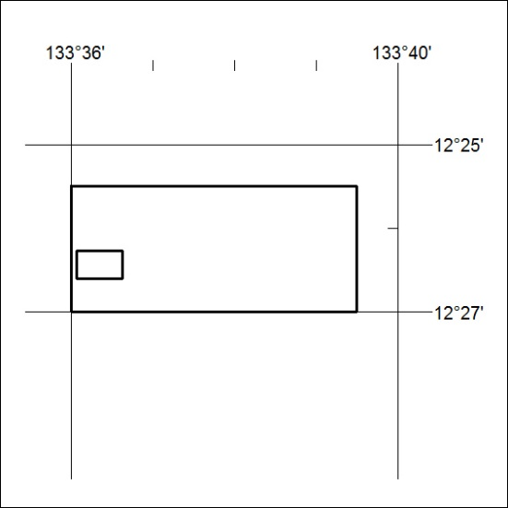

600/18

