Mineral Titles Act 2010
NOTICE OF LAND CEASING TO BE A MINERAL TITLE AREA
Title Type and Number: | Exploration Licence 31782
Area Ceased on: | 13 September 2019
Area: | 173 Blocks, 546.16 km²
Locality: | GLEN HELEN
Name of Applicant(s)/Holder(s): | 100% SCRIVEN EXPLORATION PTY LTD [ACN. 006 264 615]
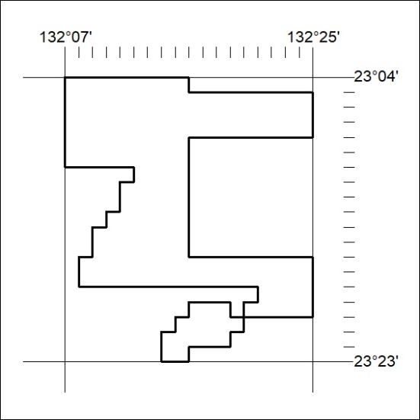

385/19

Mineral Titles Act 2010
NOTICE OF LAND CEASING TO BE A MINERAL TITLE AREA
Title Type and Number: | Exploration Licence 31783
Area Ceased on: | 13 September 2019
Area: | 215 Blocks, 678.64 km²
Locality: | NARWIETOOMA
Name of Applicant(s)/Holder(s): | 100% SCRIVEN EXPLORATION PTY LTD [ACN. 006 264 615]
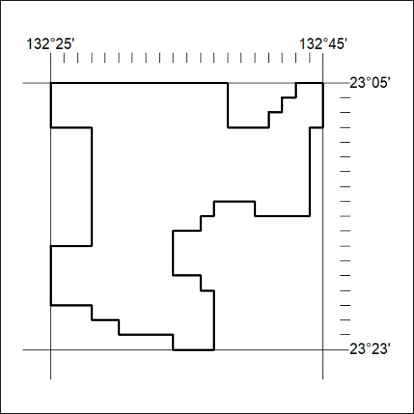

386/19

