Mineral Titles Act
NOTICE OF LAND CEASING TO BE A MINERAL TITLE AREA
Title Type and Number: | Exploration Licence 31834
Area Ceased on: | 27 November 2018
Area: | 25 Blocks, 68.96 km²
Locality: | TENNANT CREEK
Name of Applicant(s)/Holder(s): | 100% GIANTS REEF EXPLORATION PTY LTD* [ACN. 009 200 346]
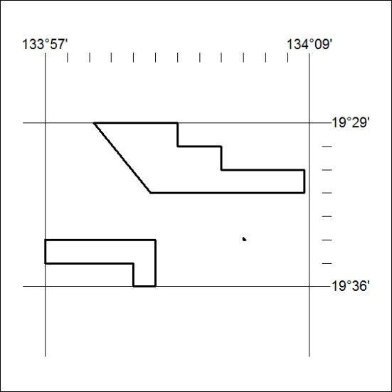

548/18

