Mineral Titles Act 2010
NOTICE OF LAND CEASING TO BE A MINERAL TITLE AREA
Title Type and Number: | Exploration Licence 31350
Area Ceased on: | 26 June 2019
Area: | 53 Blocks, 162.40 km²
Locality: | TIPPERARY
Name of Applicant(s)/Holder(s): | 100% NEWMONT GOLDCORP EXPLORATION PTY LTD* [ACN. 006 306 690]
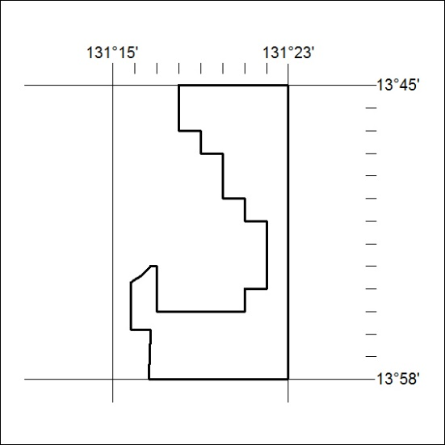

268/19

Mineral Titles Act 2010
NOTICE OF LAND CEASING TO BE A MINERAL TITLE AREA
Title Type and Number: | Exploration Licence 31421
Area Ceased on: | 26 June 2019
Area: | 14 Blocks, 42.02 km²
Locality: | JINDUCKIN
Name of Applicant(s)/Holder(s): | 100% COPPEROZ PTY LTD [ACN. 603 957 124]
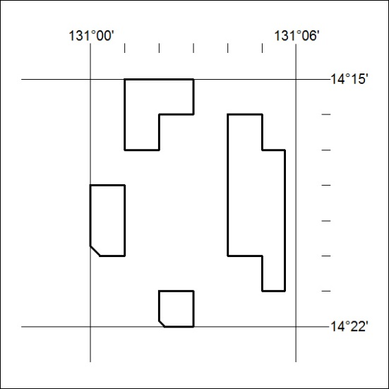

269/19

