Mineral Titles Act 2010
NOTICE OF LAND CEASING TO BE A MINERAL TITLE AREA
Title Type and Number: | Exploration Licence 8797
Area Ceased on: | 22 July 2020
Area: | 2 Blocks, 5.71 km²
Locality: | TANAMI
Name of Applicant(s)/Holder(s): | 60% TANAMI (NT) PTY LTD [ACN. 141 658 933], 40% NORTHERN STAR (TANAMI) PTY LTD [ACN. 603 860 831]
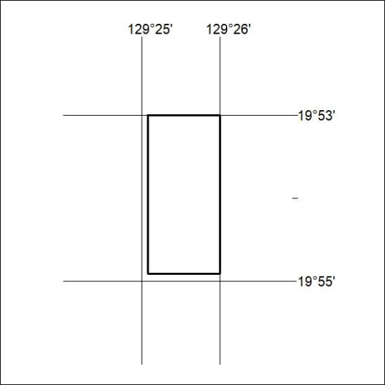

234/20

Mineral Titles Act 2010
NOTICE OF LAND CEASING TO BE A MINERAL TITLE AREA
Title Type and Number: | Exploration Licence 9763
Area Ceased on: | 22 July 2020
Area: | 7 Blocks, 17.67 km²
Locality: | FRANKENIA
Name of Applicant(s)/Holder(s): | 60% TANAMI (NT) PTY LTD [ACN. 141 658 933], 40% NORTHERN STAR (TANAMI) PTY LTD [ACN. 603 860 831]
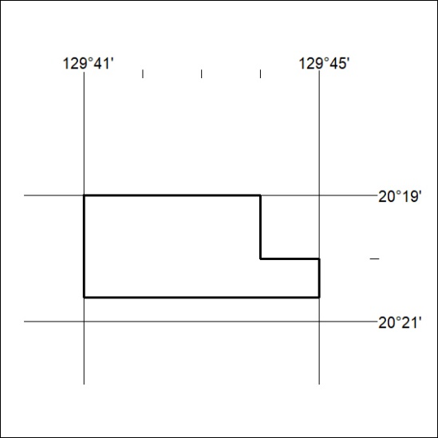

235/20
Mineral Titles Act 2010
NOTICE OF LAND CEASING TO BE A MINERAL TITLE AREA
Title Type and Number: | Exploration Licence 10355
Area Ceased on: | 22 July 2020
Area: | 4 Blocks, 12.88 km²
Locality: | FRANKENIA
Name of Applicant(s)/Holder(s): | 60% TANAMI (NT) PTY LTD [ACN. 141 658 933], 40% NORTHERN STAR (TANAMI) PTY LTD [ACN. 603 860 831]
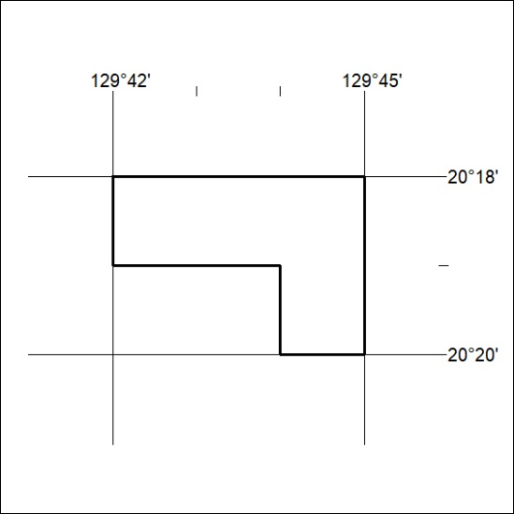

236/20

Mineral Titles Act 2010
NOTICE OF LAND CEASING TO BE A MINERAL TITLE AREA
Title Type and Number: | Exploration Licence 22229
Area Ceased on: | 22 July 2020
Area: | 8 Blocks, 25.75 km²
Locality: | GRANITES
Name of Applicant(s)/Holder(s): | 60% TANAMI (NT) PTY LTD [ACN. 141 658 933], 40% NORTHERN STAR (TANAMI) PTY LTD [ACN. 603 860 831]
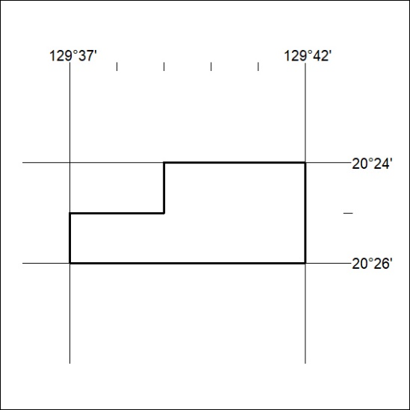

237/20
Mineral Titles Act 2010
NOTICE OF LAND CEASING TO BE A MINERAL TITLE AREA
Title Type and Number: | Exploration Licence 23342
Area Ceased on: | 22 July 2020
Area: | 8 Blocks, 25.77 km²
Locality: | FRANKENIA
Name of Applicant(s)/Holder(s): | 60% TANAMI (NT) PTY LTD [ACN. 141 658 933], 40% NORTHERN STAR (TANAMI) PTY LTD [ACN. 603 860 831]
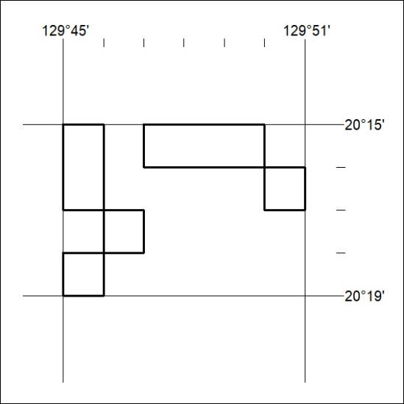

238/20

Mineral Titles Act
NOTICE OF GRANT OF A MINERAL TITLE
Title Type and Number: | Mineral Lease 26659
Granted: | 21 July 2020, for a period of 25 Years
Area: | 1404.00 Hectares
Locality: | AILERON
Name of Holder/s: | 100% ARAFURA RARE EARTHS PTY LTD [ACN. 118 158 900]
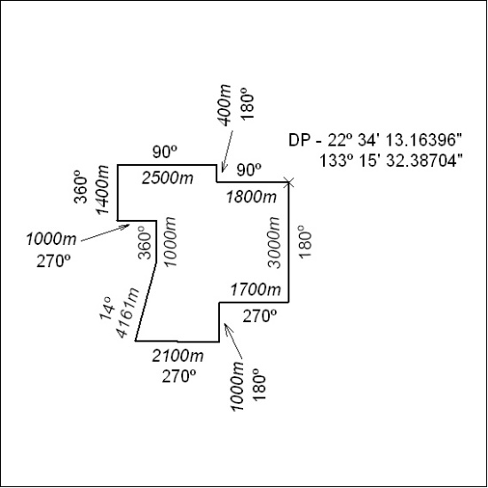

239/20

Mineral Titles Act
NOTICE OF GRANT OF A MINERAL TITLE
Title Type and Number: | Mineral Lease 30702
Granted: | 21 July 2020, for a period of 25 Years
Area: | 72.18 Hectares
Locality: | AILERON
Name of Holder/s: | 100% ARAFURA RARE EARTHS PTY LTD [ACN. 118 158 900]
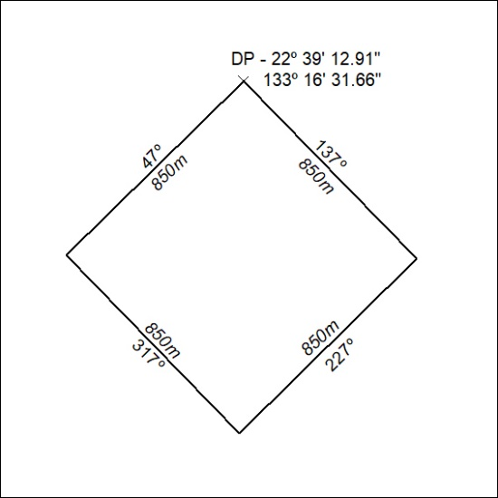

240/20

Mineral Titles Act
NOTICE OF GRANT OF A MINERAL TITLE
Title Type and Number: | Mineral Lease 30703
Granted: | 21 July 2020, for a period of 25 Years
Area: | 1384.00 Hectares
Locality: | AILERON
Name of Holder/s: | 100% ARAFURA RARE EARTHS PTY LTD [ACN. 118 158 900]
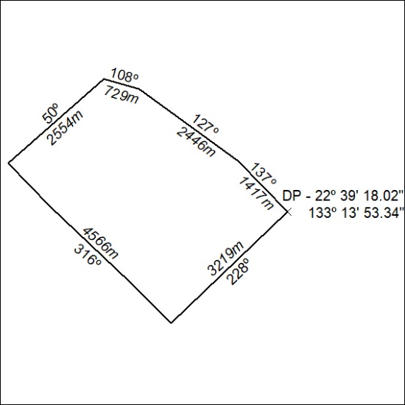

241/20

Mineral Titles Act
NOTICE OF GRANT OF A MINERAL TITLE
Title Type and Number: | Mineral Lease 30704
Granted: | 21 July 2020, for a period of 25 Years
Area: | 207.30 Hectares
Locality: | AILERON
Name of Holder/s: | 100% ARAFURA RARE EARTHS PTY LTD [ACN. 118 158 900]
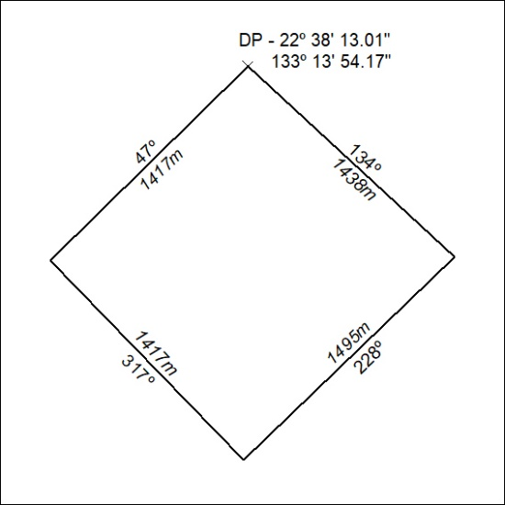

242/20

