Mineral Titles Act
NOTICE OF LAND CEASING TO BE A MINERAL TITLE AREA
Title Type and Number: | Extractive Mineral Exploration Licence 30983
Area Ceased on: | 16 June 2018
Area: | 4 Blocks, 10.55 km²
Locality: | BYNOE
Name of Applicant(s)/Holder(s): | 100% A AND SF MADDALOZZO PTY. LIMITED [ACN. 009 624 015]
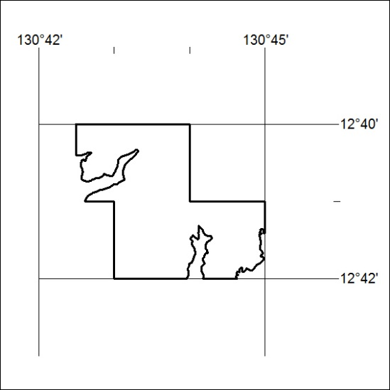

271/18

Mineral Titles Act
NOTICE OF LAND CEASING TO BE A MINERAL TITLE AREA
Title Type and Number: | Extractive Mineral Exploration Licence 31009
Area Ceased on: | 15 June 2018
Area: | 4 Blocks, 12.16 km²
Locality: | MARY RIVER
Name of Applicant(s)/Holder(s): | 50% DOYLE Nigel John, 50% EASTICK Peter Robert
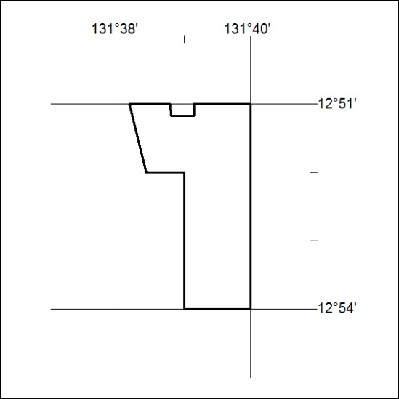

272/18

