Agnote

No: D45
May 2014

Degradable Mulch Trials
S. Smith and H. Wallace, Plant Industries, Darwin

Background
Plastic mulch is commonly used in the Northern Territory (NT) in conjunction with drip tape irrigation for growing sweet melons and vegetables. The irrigation tape can be buried slightly or can be laid on the soil surface and then covered with the plastic mulch. Plastic mulch helps to control weeds, improve water use efficiency by lowering evaporation and increase crop yields.
It is estimated that the NT has 987 hectares under melon production. Based on 1.5-metre rows, this equates to 6.6 km of plastic mulch per hectare. The total length of plastic mulch used in the NT every year is therefore 6514 km. Based on a common commercial roll being 2.3 km long, approximately 2832 rolls of plastic mulch are used per year. As each roll weighs 66 kg, the total weight of plastic mulch waste for disposal every year is 187 tonnes. This does not take into account the plastic mulch used on other vegetables, such as Asian melons, cucumber, okra and snake beans. Therefore, the total amount of plastic mulch to be disposed of every year in the NT is close to 200 tonnes.
Over the past few years, degradable mulch technology has been developing to tackle the problem of plastic waste disposal. The technology belongs to the manufacturer, and is often protected commercially. Some mulches are made from cellulose or starch and break down through normal biological processes. Other mulches are made from normal polyethylene that contains a chemical-degrading agent that shortens the length of the polyethylene chain, making it more exposed to microbial degradation.
Even though the technology to degrade plastic mulch is a positive outcome, there are management risks with its use. Questions remain about the breakdown of these mulches to greenhouse gases, the toxicity of breakdown products, the possibility of small pieces of mulch creating a mess and the efficacy of the products compared with conventional mulches. Cost comparisons show that some degradable mulch is approximately 15 to 30% more expensive than conventional mulch.

Trials in the NT
The Department of Primary Industry and Fisheries, in collaboration with the NT Farmers Association, AgNova, Econverte and Novomont conducted simple trials at Berrimah Farm in 2012 and 2013 to determine the efficacy of biodegradable mulches for use in the NT. A number of vegetables, including sweet corn, tomatoes, eggplants and pumpkins, as well as watermelons were grown using plastic mulch. The trials were conducted during both the wet and dry seasons. The results were as follows:

Degricover - 2012-13 wet season
Econverte Degricover three month and six month (black) was useful in the wet season of 2012-13 and remained intact from when it was laid on 6 December 2012, with only small amounts of splitting until watermelons were harvested in February 2013. It did eventually split during and after harvesting the watermelons; it continued to break down until 22 April 2013, when the remaining mulch was pulled up so that the ground could be reworked for a dry season crop. There was no observable difference between the three-month and six-month Degricover. According to the manufacturer, the three month rolls were designed to break down after three months, and the six month rolls, after six months. Our experience showed that appreciable, but not total, breakdown occurred after five months in both. It should be noted that the wet season had below average rainfall, which may have affected the trial results. The crops were watered twice daily to ensure there was always moisture under the mulch.
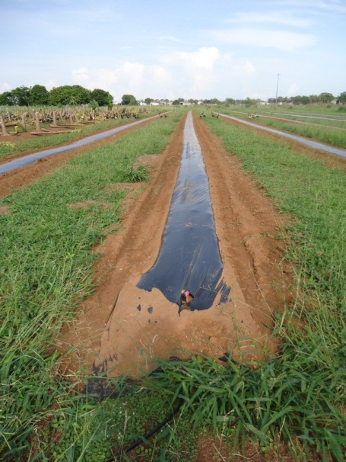 | 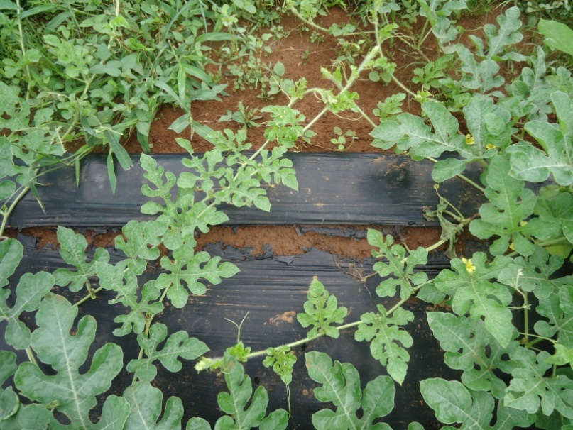
Figure 1. Ecoconverte Degricover three month 17 December 2012, 11 days after laying | Figure 2. Ecoconverte Degricover three month 14 February 2013, 70 days after laying (close up)

Agnove e-film – 2012-13 wet season
Agnova efilm was not robust in the wet season of 2012-13 and started to break apart after 18 days. It was not useful as an alternative to conventional mulch. The buried portion of the mulch did, however, last longer and could still be found 10 months after laying. The supplier said that the batch used did have problems that were subsequently rectified. We have not tested any new product yet.
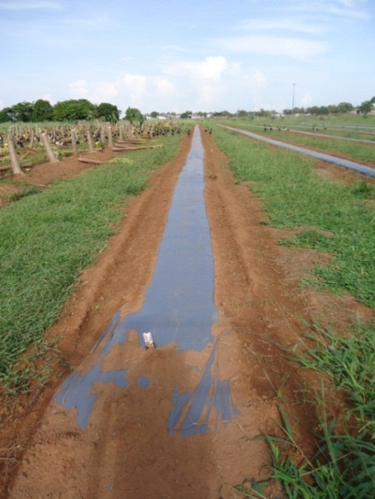 | 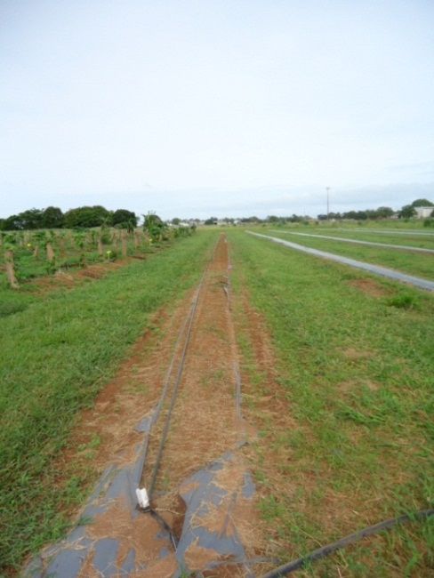
Figure 3. Agnova e-film 17 December 2012, 11 days after laying | Figure 4. Agnova e-film 7 January 2013, 32 days after laying

Degricover – 2013 Dry season
Econverte Degricover three month black/black and white/black was useful to mulch watermelons, sweet corn, eggplants, tomatoes and pumpkins in the dry season of 2013. It was robust through the duration of all these crops and was intact from 8 May to 19 September (134 days or just over four months). This was enough time for all the crops to go through their cycle until harvest. There was some splitting and breakdown, more in the black mulch than in the white mulch. On 26 November, the condition of the mulch was reassessed. It was found to be very fragile and split, but was still intact.
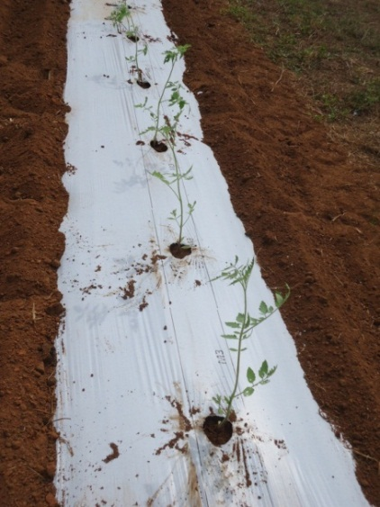 | 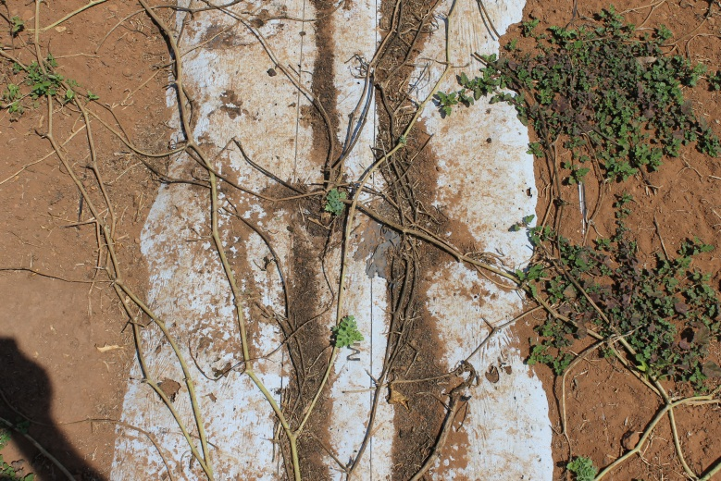
Figure 5. Econverte three month white/black 17 May 2013, 11 days after laying, with tomato seedlings | Figure 6. Econverte three month white/black 19 September 2013, 134 days after laying; watermelons had been already harvested

Novomont – 2013 late dry season
Novomont Mater-Bi CE04P and EF04P were laid with Econverte three month black/black in a new trial, which started on 2 August 2013 on rough ground. The sticks and stones in the rough ground damaged the Novomont products; one row was further damaged by wind and magpie geese. The Econverte product was more resilient in this tougher environment. Pumpkins, watermelons and sweet corn were planted in this trial. By 74 days after laying (mid-October), all plastic types had split open and were very thin and brittle. The trial area was sprayed with glyphosate in early November and, after all the vegetation had died, the area was cultivated with tines (Triple K) on 20 November and most of the mulch was worked into the soil very easily. Some of the mulch got attached to the tines and was hand-cleared at the paddock edge. Very little residue was left after cultivation.
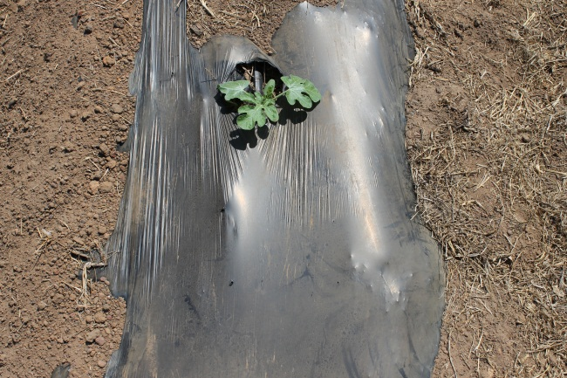 | 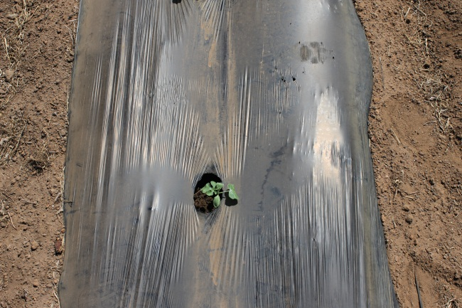
Figure 7. Novomont Mater Bi CE04P, 19 September 2013, 38 days after laying | Figure 8. Novomont Mater Bi EF04P, 19 September 2013, 38 days after laying

CONCLUSIONS
No commercial degradable mulch can be confidently recommended at this stage. None of the mulches we have tested so far have been able to meet all the desired requirements i.e. being strong enough to withstand varied conditions at laying, remain intact over the course of the growing season and breakdown rapidly when cultivated at the end. Manufacturer activity in this area is highly competitive and several companies are developing degradable mulches based on a number of technologies. It is expected that with further research and development, adequate degradable mulches will be found for NT conditions.

Please visit us at our website:
www.nt.gov.au/d

© Northern Territory Government
ISSN 0157-8243
Serial No. 851
Agdex No. 260/16

Disclaimer: While all care has been taken to ensure that information contained in this document is true and correct at the time of publication, the Northern Territory of Australia gives no warranty or assurance, and makes no representation as to the accuracy of any information or advice contained in this publication, or that it is suitable for your intended use. No serious, business or investment decisions should be made in reliance on this information without obtaining independent and/or professional advice in relation to your particular situation.

