Mineral Titles Act
NOTICE OF LAND CEASING TO BE A MINERAL TITLE AREA
Title Type and Number: | Exploration Licence 31276
Area Ceased on: | 17 December 2018
Area: | 4 Blocks, 13.35 km²
Locality: | PINE CREEK
Name of Applicant(s)/Holder(s): | 100% ROCKWASH PTY LTD [ACN. 611 356 837]
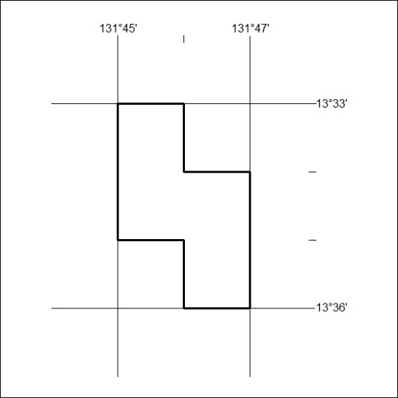

583/18

