Mineral Titles Act 2010
NOTICE OF LAND CEASING TO BE A MINERAL TITLE AREA
Title Type and Number: | Extractive Mineral Permit 28876
Area ceased on: | 23 March 2020
Area: | 32.00 Hectare
Locality: | TENNANT CREEK
Name of Applicants(s)Holder(s): | 100% PHILLIPS Edward James
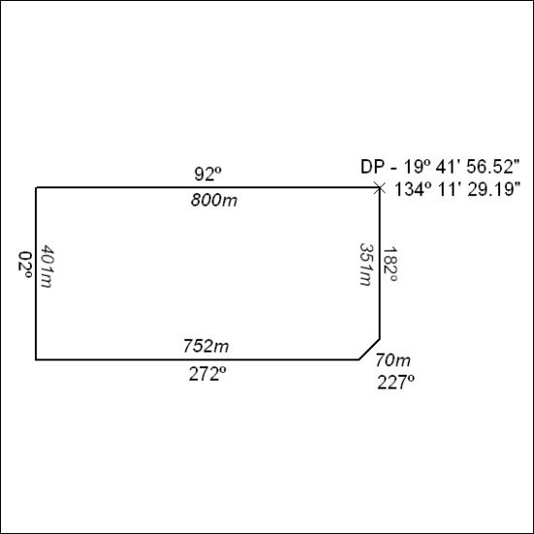
154/20

Corrigendum
Notice Number 153/20 appearing in MN33/20 on 24 March 2020 is hereby cancelled and replaced by the following:

155/20

Mineral Titles Act
NOTICE OF GRANT OF A MINERAL TITLE
Title Type and Number: | Exploration Licence 32244
Granted: | 20 March 2020, for a period of 6 Years
Area: | 204 Blocks, 639.68 km²
Locality: | TODD
Name of Holder/s: | 100% GEMPART (NT) PTY LTD* [ACN. 081 859 896]
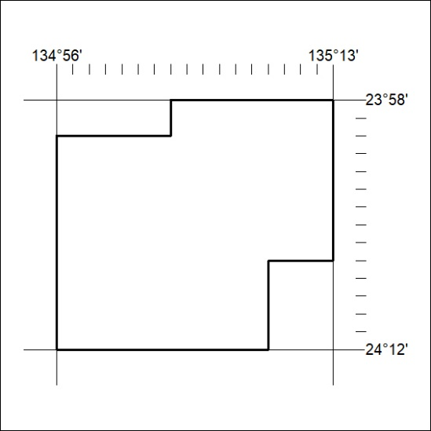
Area granted is indicated above. The titleholder is not permitted to exercise occupational rights on any land that is subject to a development title, or an application for a development title. Any land the subject of a Reserved Land gazettal under the Mineral Titles Act and all land vested in the Commonwealth of Australia is also excluded by description but not excised from the grant area.

