Mineral Titles Act
NOTICE OF GRANT OF A MINERAL TITLE
Title Type and Number: | Extractive Mineral Permit 31697
Granted: | 13 March 2018, for a period of 5 Years
Area: | 0.45 Hectare
Locality: | NOONAMAH
Name of Holder/s: | 100% BIRCH Shane Alan Taylor
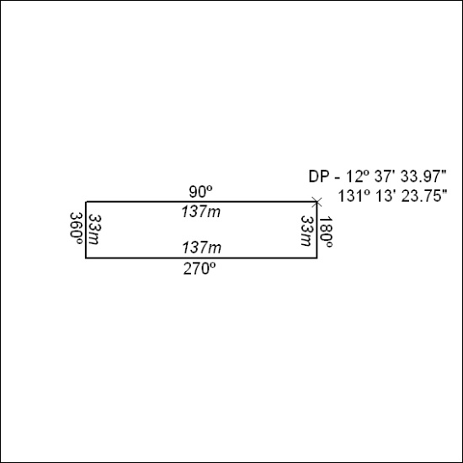

120/18

Mineral Titles Act
NOTICE OF GRANT OF A MINERAL TITLE
Title Type and Number: | Extractive Mineral Exploration Licence 31653
Granted: | 13 March 2018, for a period of 2 Years
Area: | 1 Block, 3.34 km²
Locality: | PINE CREEK
Name of Holder/s: | 100% BIRCH Shane Alan Taylor
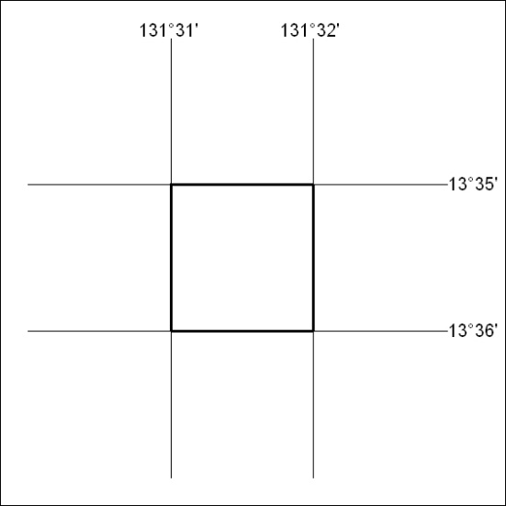
Area granted is indicated above. The titleholder is not permitted to exercise occupational rights on any land that is subject to a development title, or an application for a development title. Any land the subject of a Reserved Land gazettal under the Mineral Titles Act and all land vested in the Commonwealth of Australia is also excluded by description but not excised from the grant area.

121/18

