Mineral Titles Act
NOTICE OF GRANT OF A MINERAL TITLE
Title Type and Number: | Exploration Licence 31617
Granted: | 26 April 2018, for a period of 6 Years
Area: | 237 Blocks, 711.96 km²
Locality: | CHALUBA
Name of Holder/s: | 100% TREASURE CREEK PTY LTD [ACN. 619 057 644]
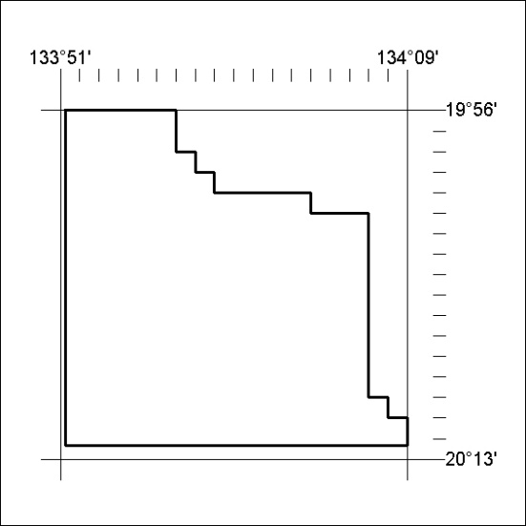
Area granted is indicated above. The titleholder is not permitted to exercise occupational rights on any land that is subject to a development title, or an application for a development title. Any land the subject of a Reserved Land gazettal under the Mineral Titles Act and all land vested in the Commonwealth of Australia is also excluded by description but not excised from the grant area.
153/18

Mineral Titles Act
NOTICE OF GRANT OF A MINERAL TITLE
Title Type and Number: | Exploration Licence 31619
Granted: | 26 April 2018, for a period of 6 Years
Area: | 244 Blocks, 743.08 km²
Locality: | GOSSE RIVER
Name of Holder/s: | 100% TREASURE CREEK PTY LTD [ACN. 619 057 644]
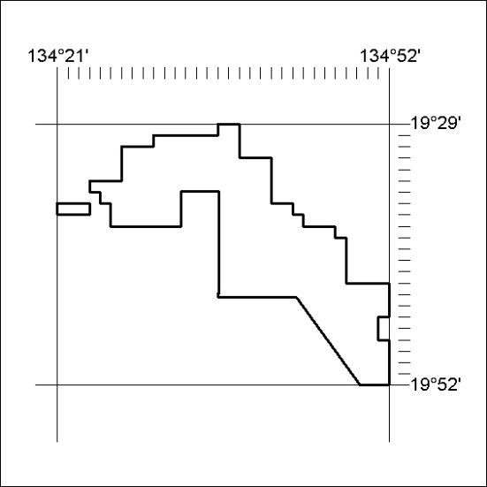
Area granted is indicated above. The titleholder is not permitted to exercise occupational rights on any land that is subject to a development title, or an application for a development title. Any land the subject of a Reserved Land gazettal under the Mineral Titles Act and all land vested in the Commonwealth of Australia is also excluded by description but not excised from the grant area.
154/18

