Mineral Titles Act
NOTICE OF LAND CEASING TO BE A MINERAL TITLE AREA
Title Type and Number: | Exploration Licence 30051
Area Ceased on: | 15 May 2018
Area: | 91 Blocks, 303.24 km²
Locality: | FLYING FOX
Name of Applicant(s)/Holder(s): | 100% MYANMAR METALS LIMITED* [ACN. 124 943 728]
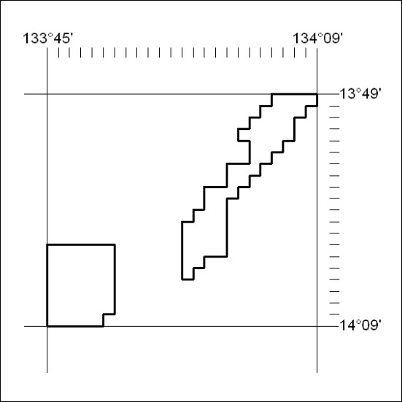

193/18

Mineral Titles Act
NOTICE OF LAND CEASING TO BE A MINERAL TITLE AREA
Title Type and Number: | Exploration Licence 31198
Area Ceased on: | 18 May 2018
Area: | 6 Blocks, 20.04 km²
Locality: | BATCHELOR
Name of Applicant(s)/Holder(s): | 100% STEPHENS Robert Dean
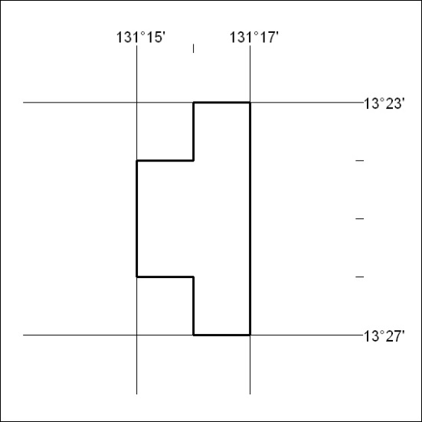

194/18

