Mineral Titles Act
NOTICE OF LAND CEASING TO BE A MINERAL TITLE AREA
Title Type and Number: | Exploration Licence 28837
Area Ceased on: | 23 January 2019
Area: | 28 Blocks, 88.71 km²
Locality: | DNEIPER
Name of Applicant(s)/Holder(s): | 100% XAVIER RESOURCES PTY LTD [ACN. 623 262 304]
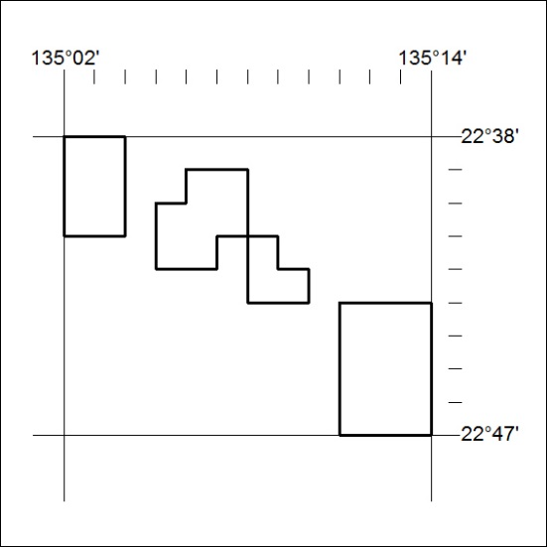

17/19

