Mineral Titles Act 2010
NOTICE OF LAND CEASING TO BE A MINERAL TITLE AREA
Title Type and Number: | Extractive Mineral Exploration Licence 31653
Area Ceased on: | 12 March 2020
Area: | 1 Block, 3.34 km²
Locality: | PINE CREEK
Name of Applicant(s)/Holder(s): | 100% BIRCH Shane Alan Taylor
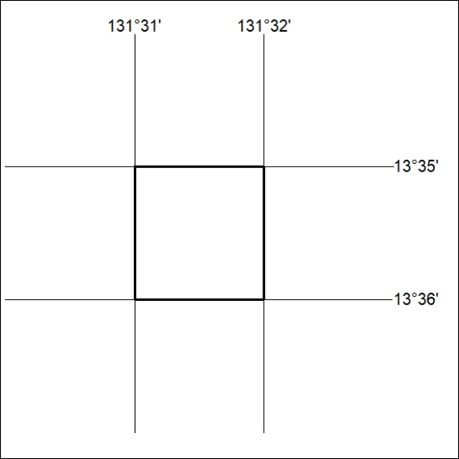

139/20

