Mineral Titles Act
NOTICE OF LAND CEASING TO BE A MINERAL TITLE AREA
Title Type and Number: | Exploration Licence 31299
Area Ceased on: | 08 June 2018
Area: | 250 Blocks, 793.99 km²
Locality: | DENISON
Name of Applicant(s)/Holder(s): | 100% LITCHFIELD MINERALS PTY LTD [ACN. 612 660 429]
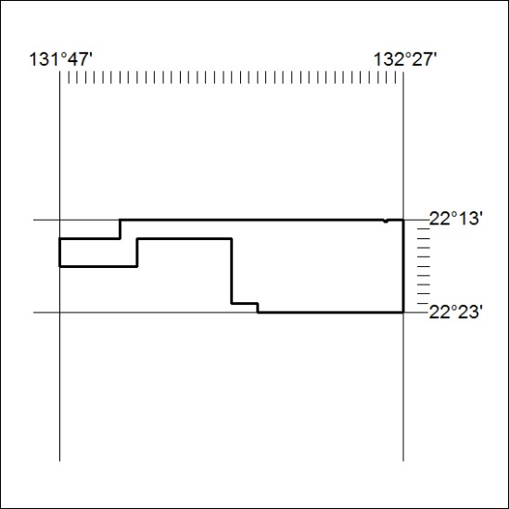

257/18

Mineral Titles Act
NOTICE OF LAND CEASING TO BE A MINERAL TITLE AREA
Title Type and Number: | Exploration Licence 31384
Area Ceased on: | 12 June 2018
Area: | 5 Blocks, 16.40 km²
Locality: | LANCEWOOD
Name of Applicant(s)/Holder(s): | 100% OCEANIC RESOURCES AND PROPERTY GROUP PTY LTD [ACN. 154 418 336]
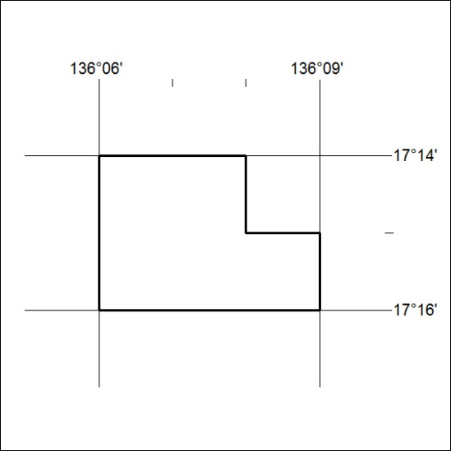

258/18

